JENKINS WEBAPP PIPELINE

By S.Asha

22BD1A059J

1. Go to the Jenkins dashboard and click on New Item
2. Give item name as web_build

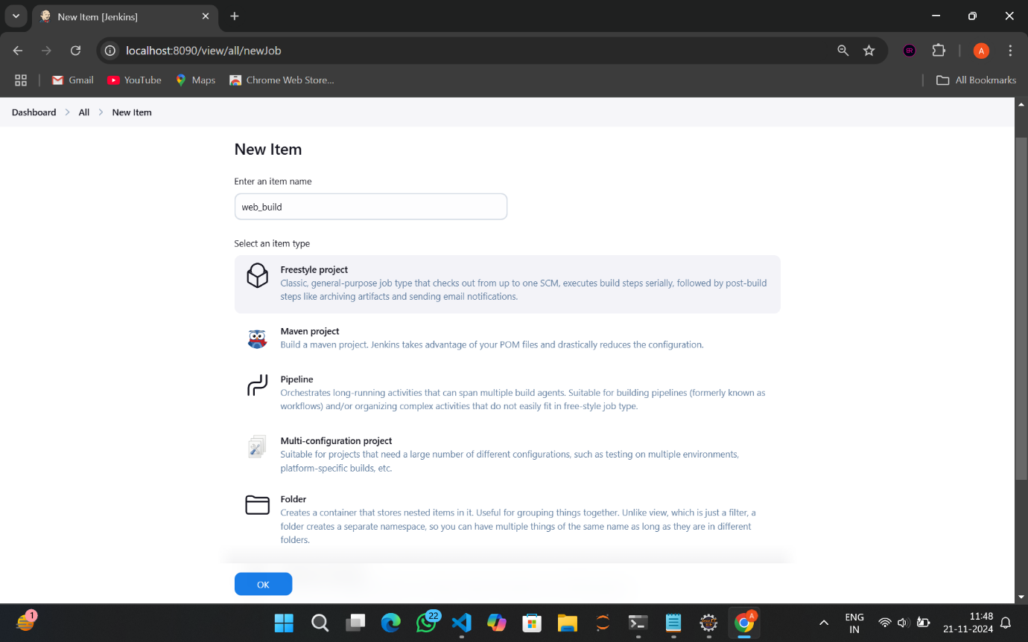

1. Select Freestyle Project and click on OK

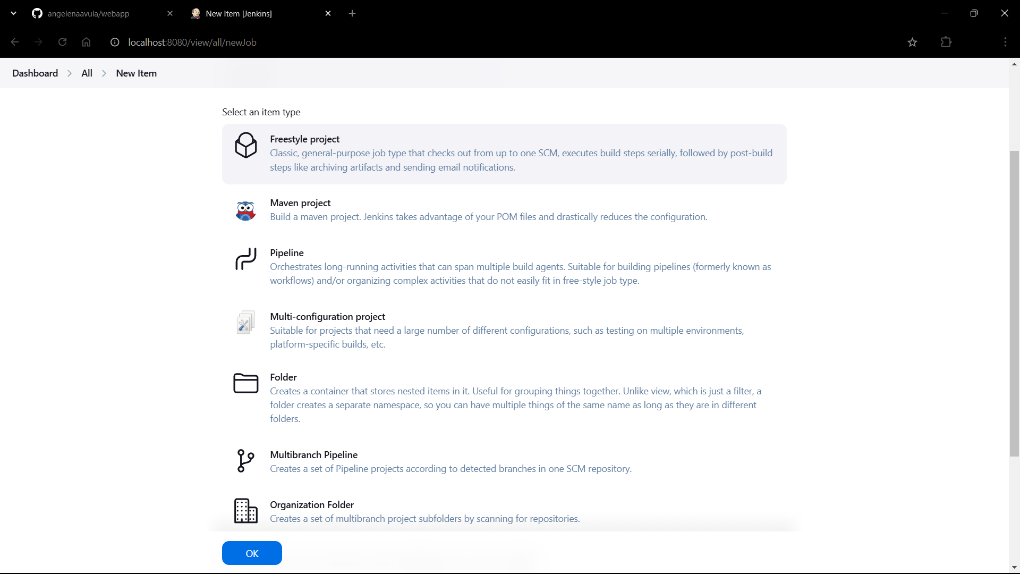

1. Scroll down and select SCM as Git

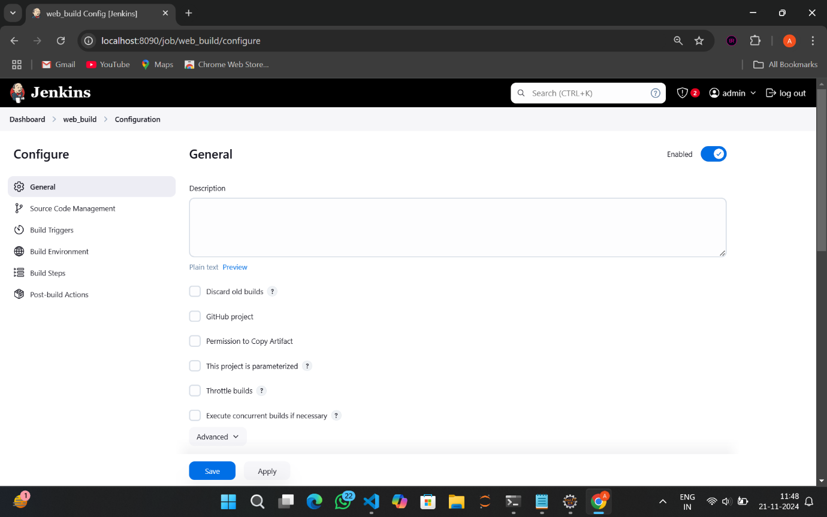

1. Go to your webapp repository and copy the repo url

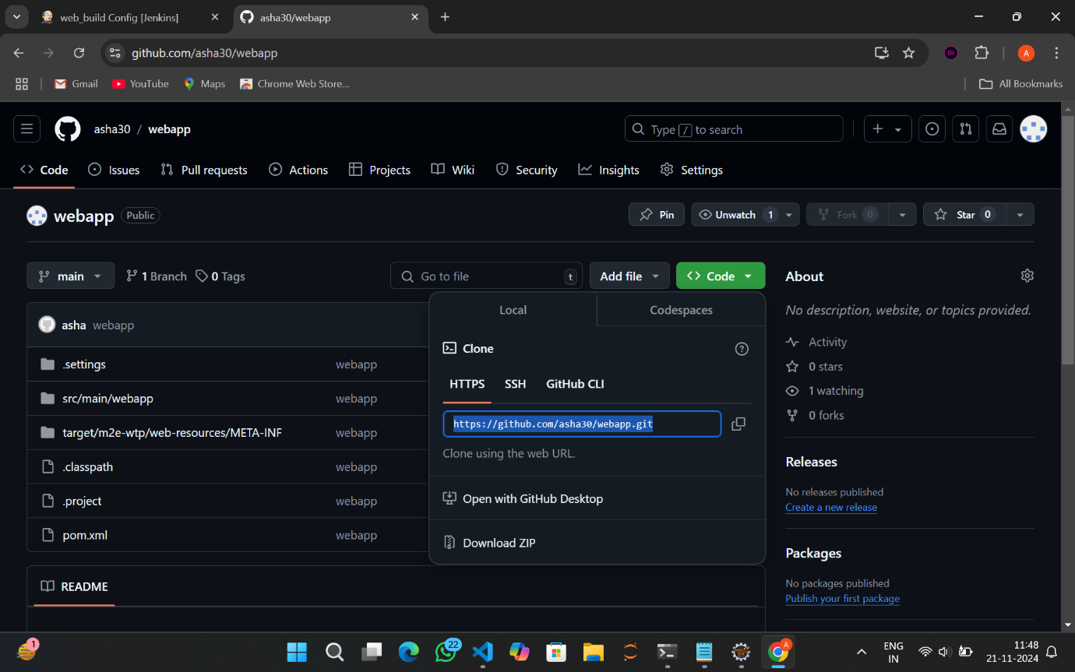

1. Paste the link at the Repository URL

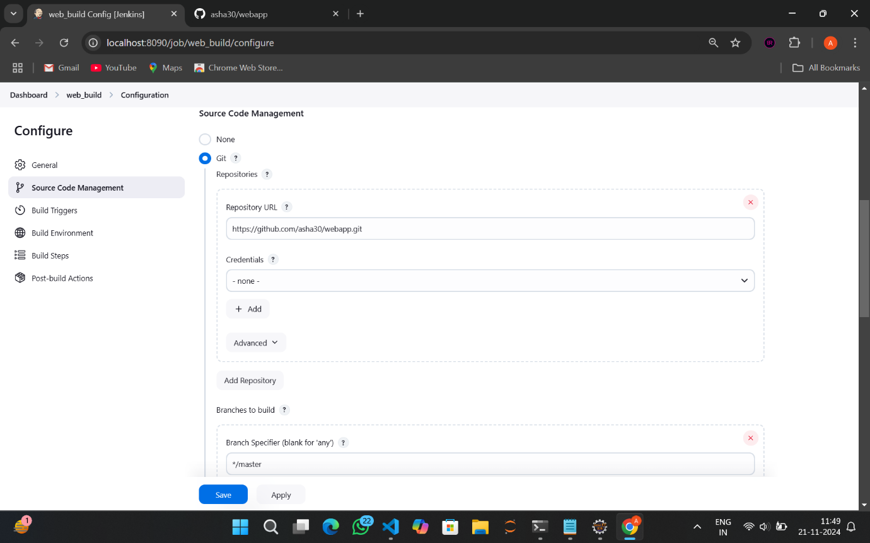

1. Specify the branch

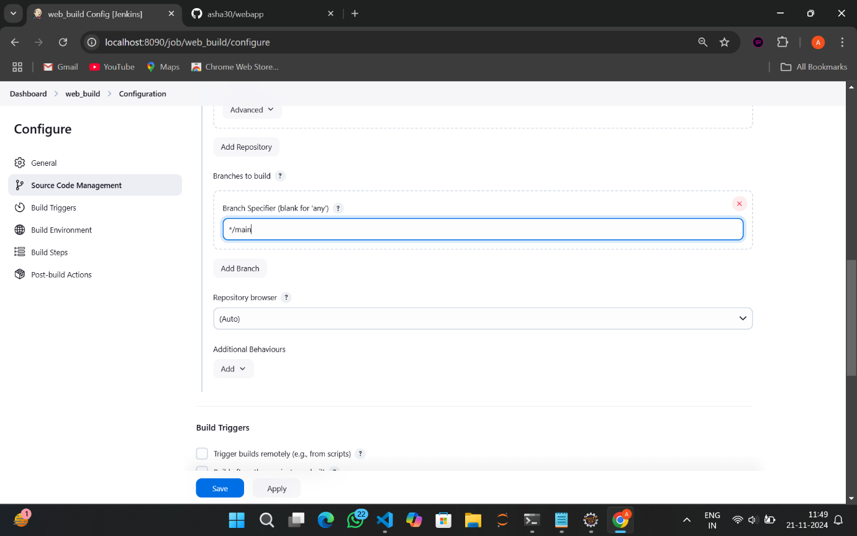

1. In build triggers select Poll SCM

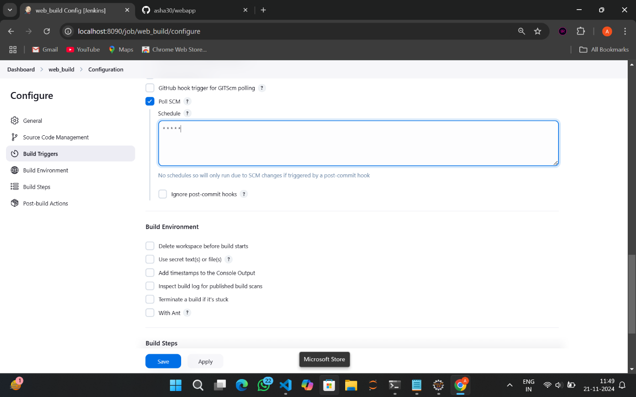

1. Give schedule as * * * * *



1. This is how it is done

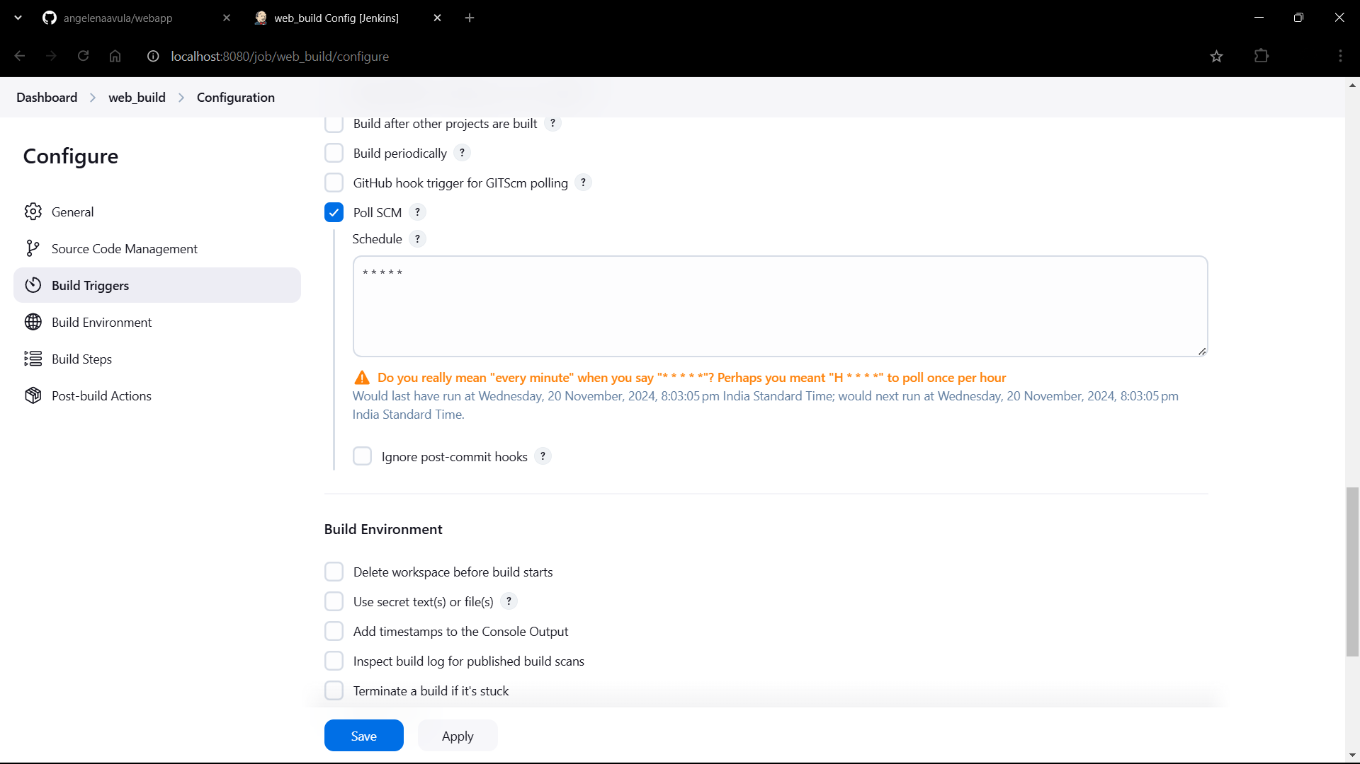

1. Go to Add build step->Invoke top level maven targets

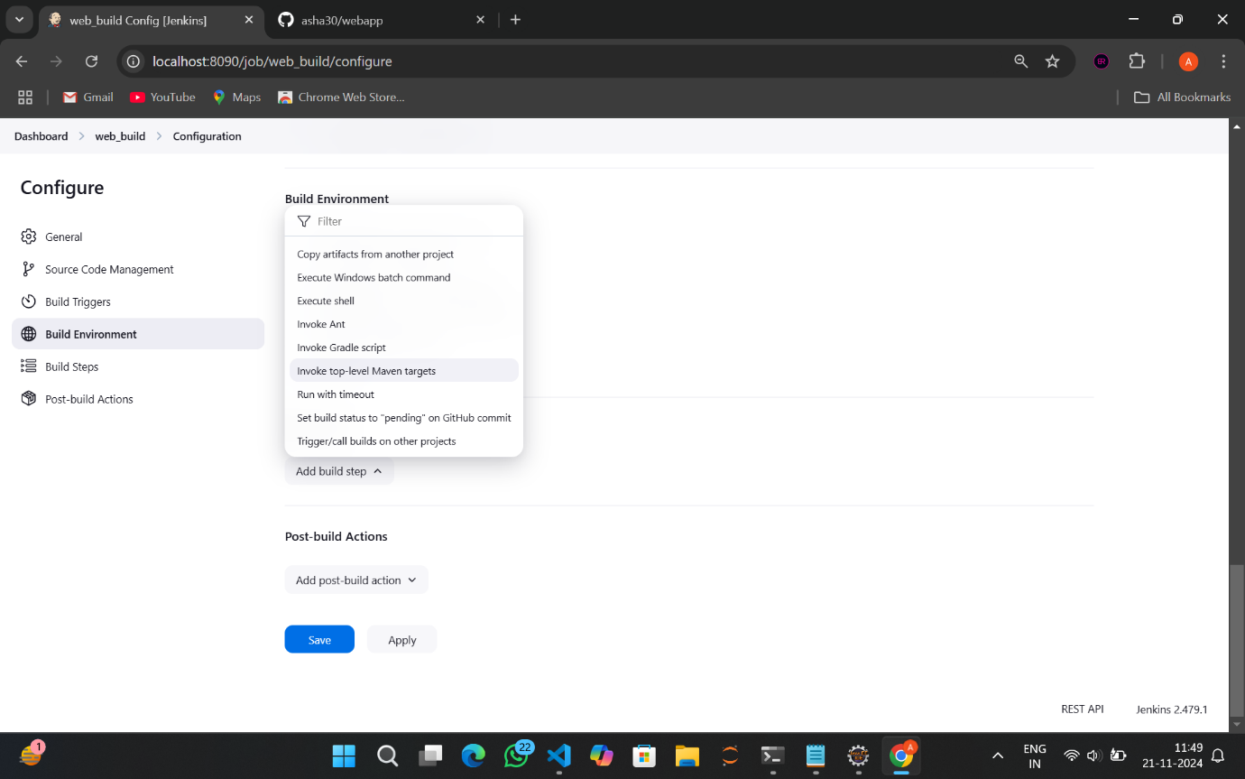

1. Give the MAVEN_HOME path

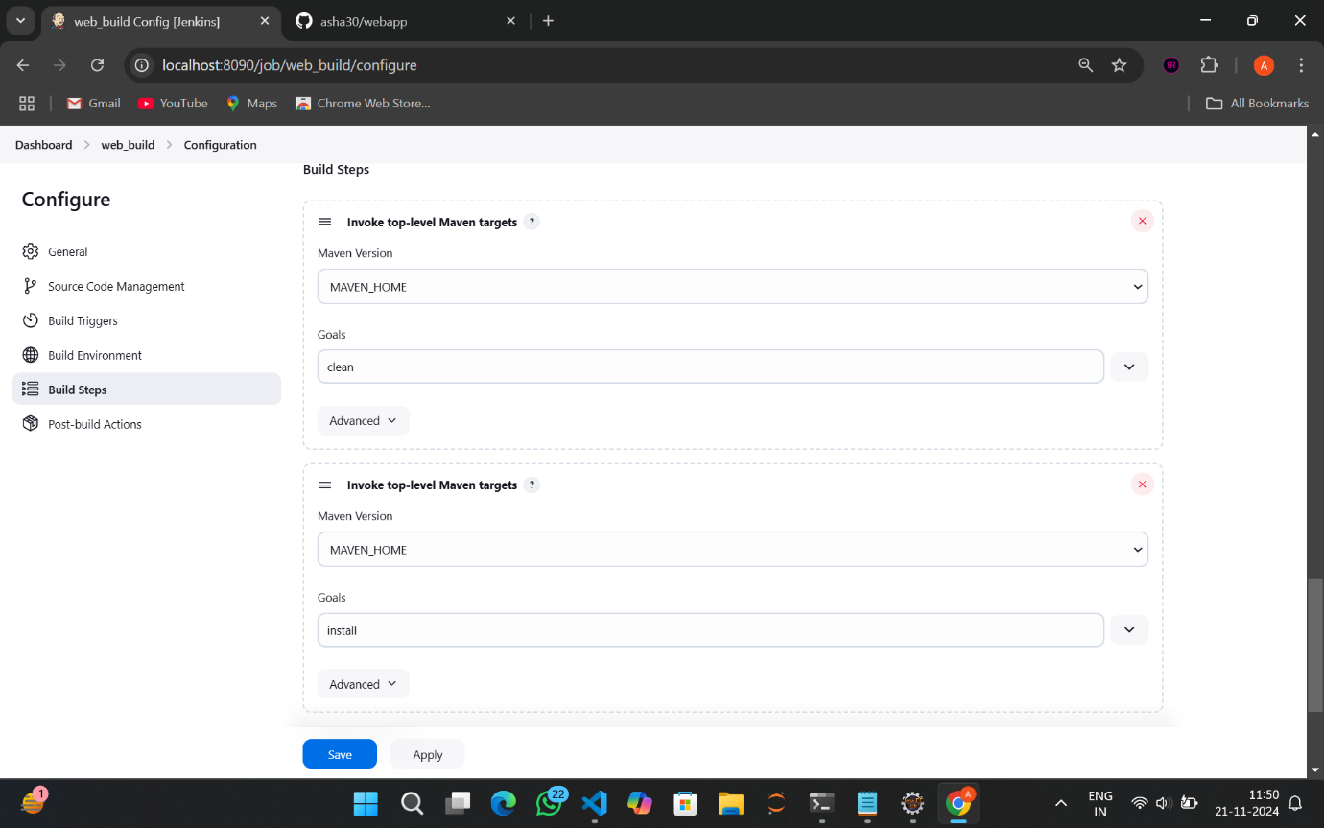

1. Give goals as clean



1. Go to Add build step->Invoke top level maven targets

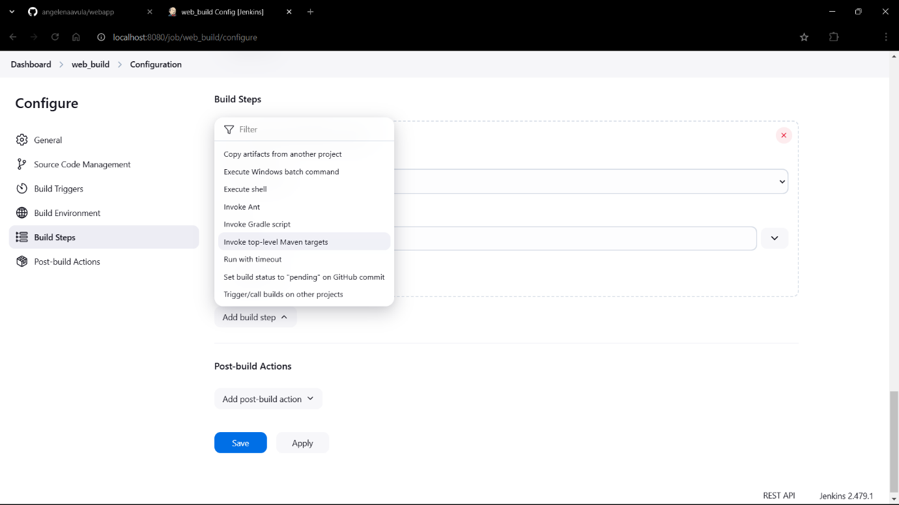

1. Give MAVEN_HOME path and goals as install



1. Go to post build action->Archive the artifacts

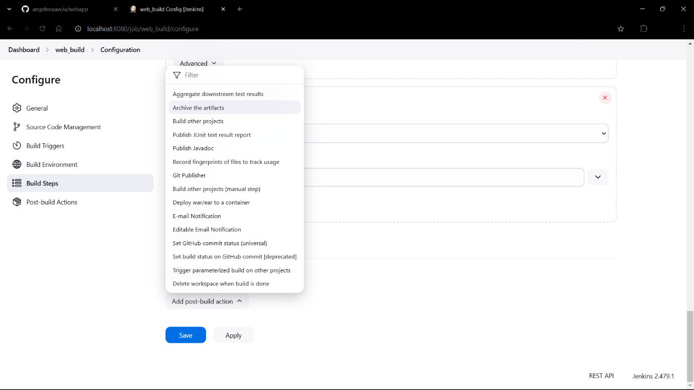

1. Give **/* as Files to archive

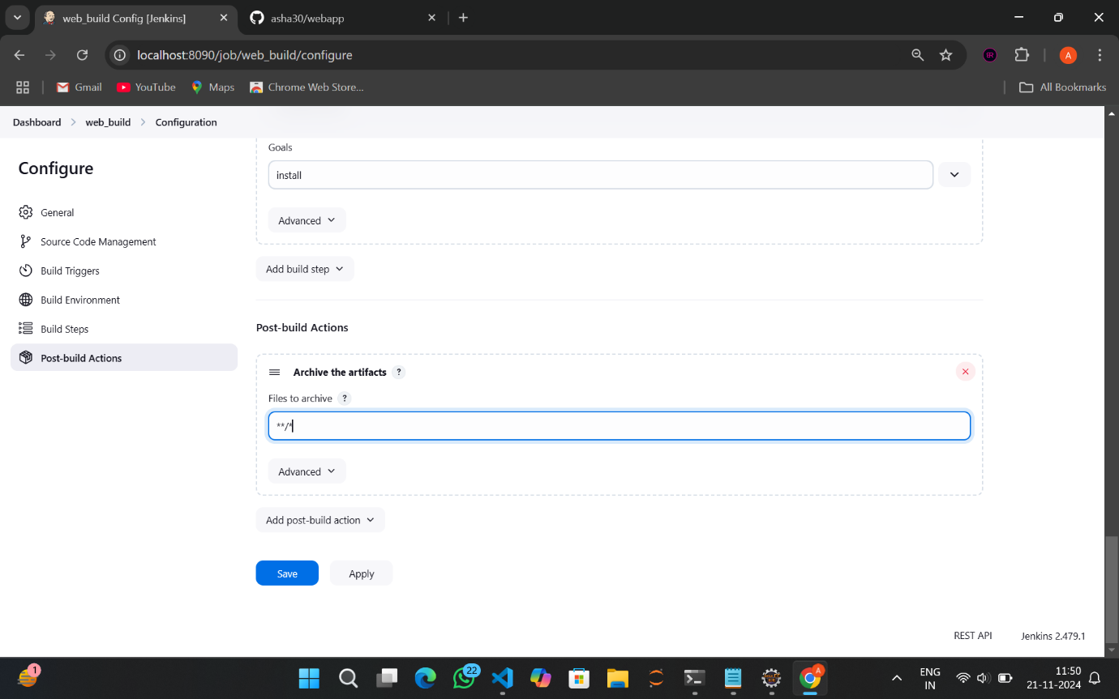

1. Go to Add post-build action->Build other projects

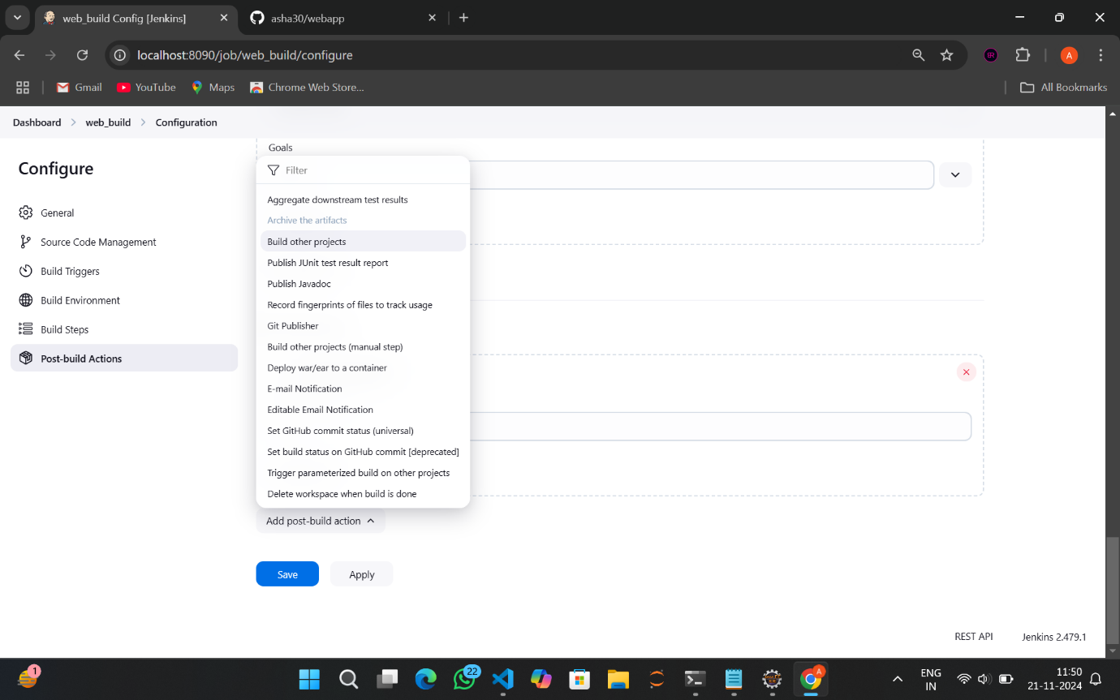

1. Give Projects to build as web_test

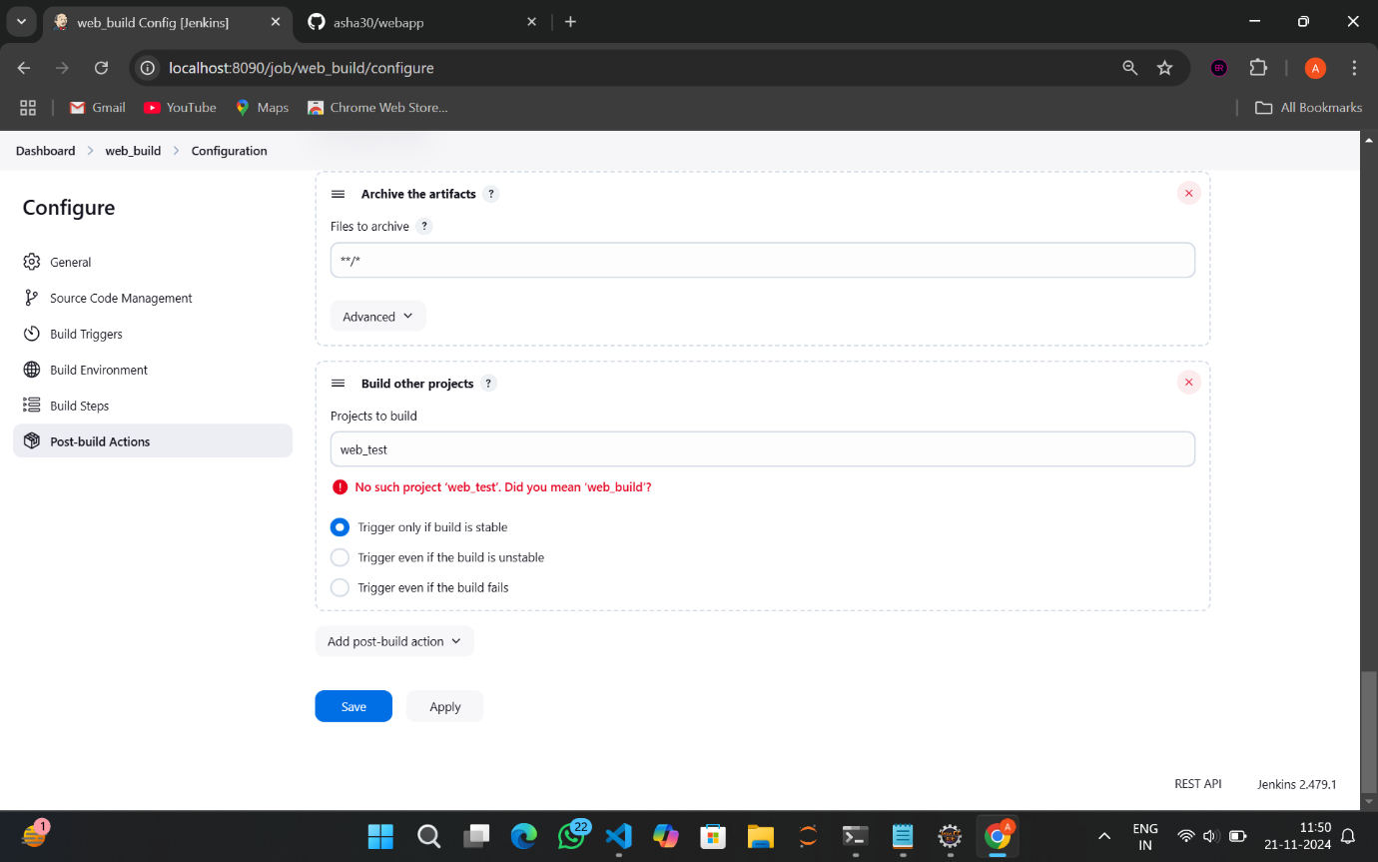

1. Click on Apply->Save



1. It was successful!!

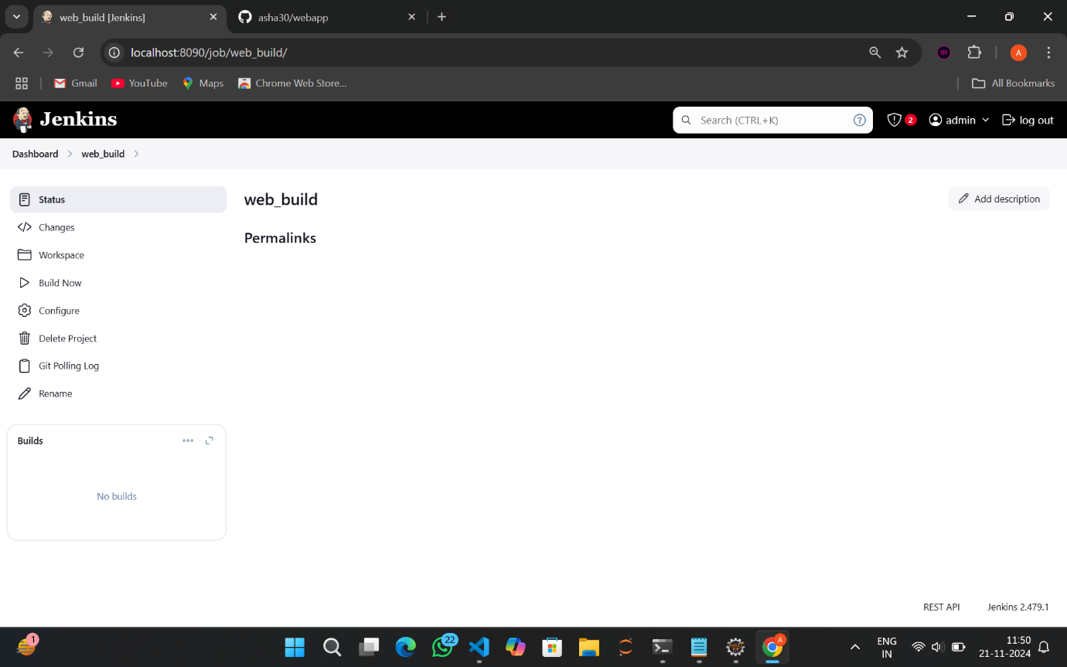

1. Go to Dashboard->New Item

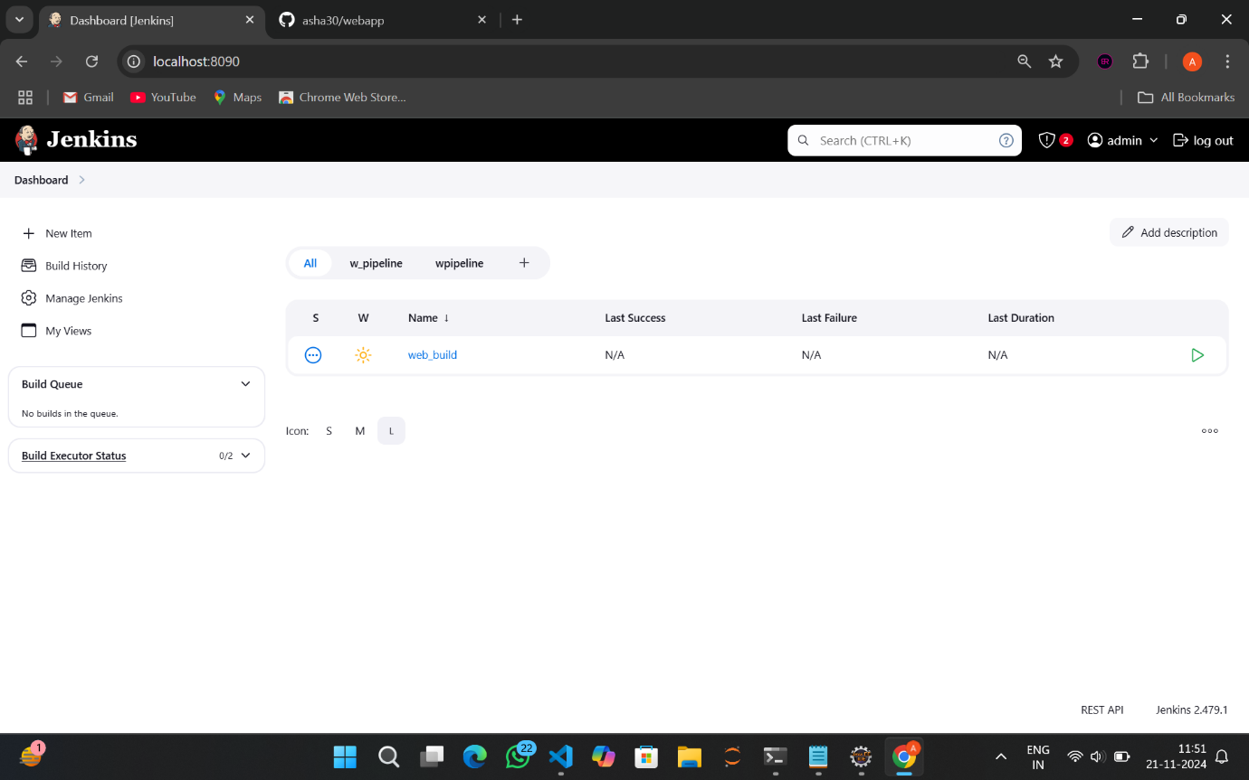

1. Give Item name as web_test->Freestyle Project->OK

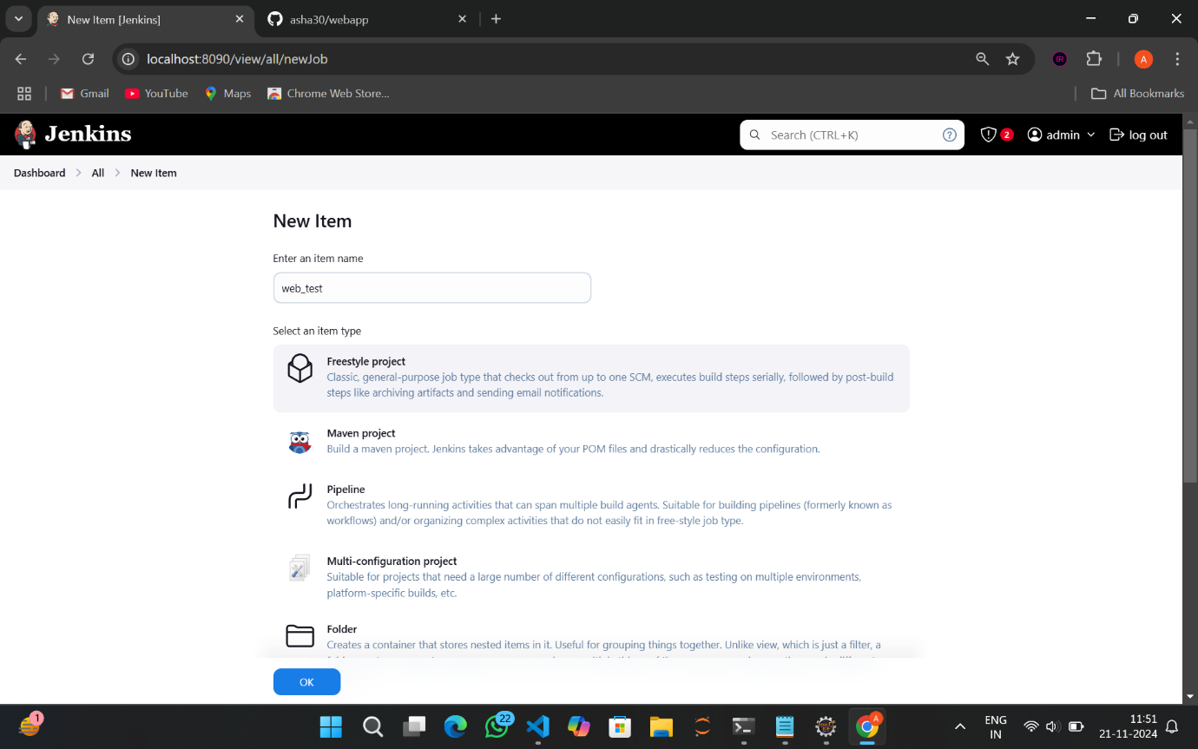

1. In Build environment select Delete workspace before build starts

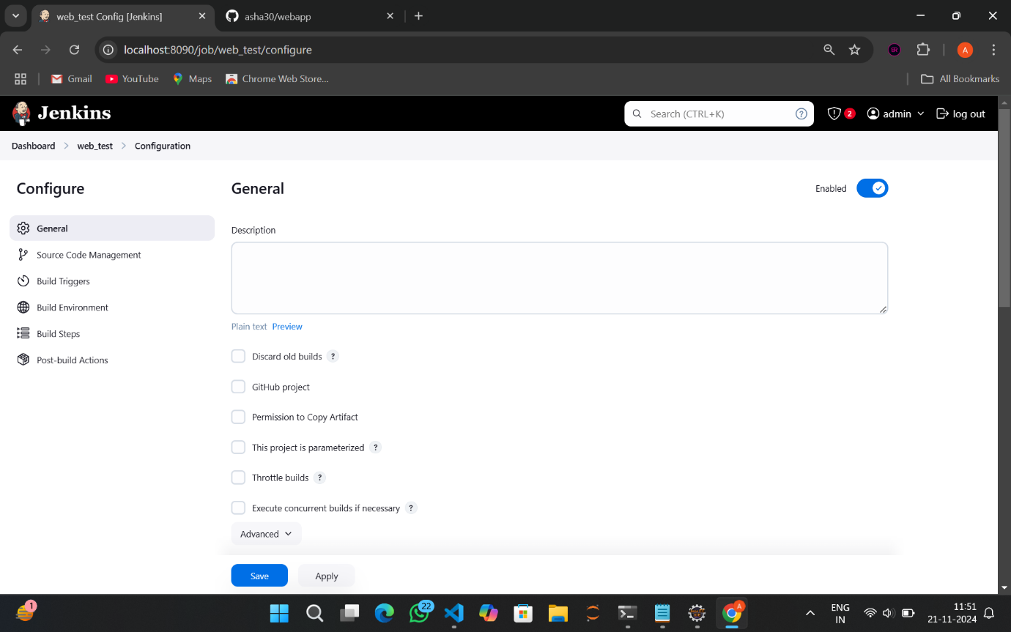

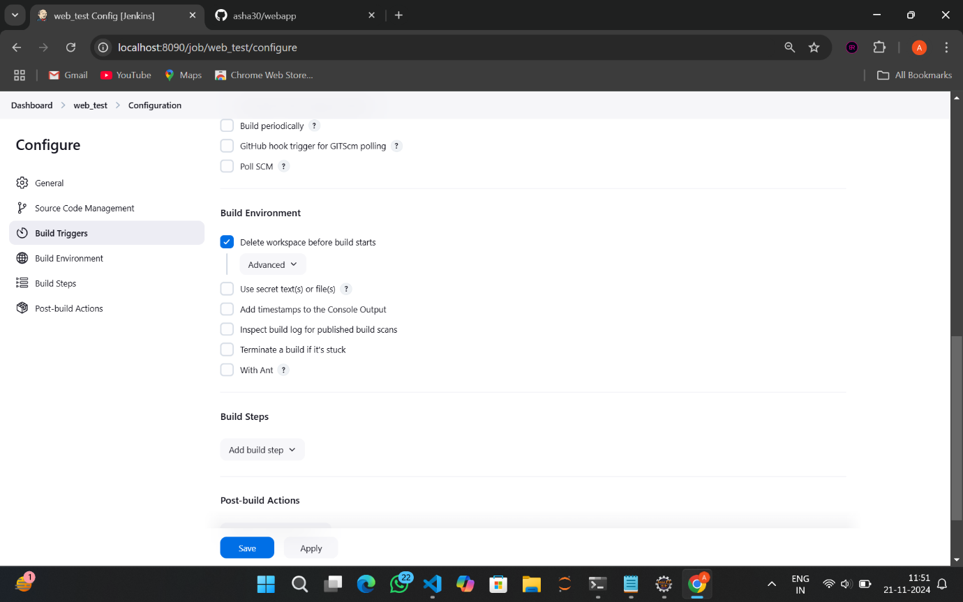

1. Go to Add build step->Copy artifacts from another project

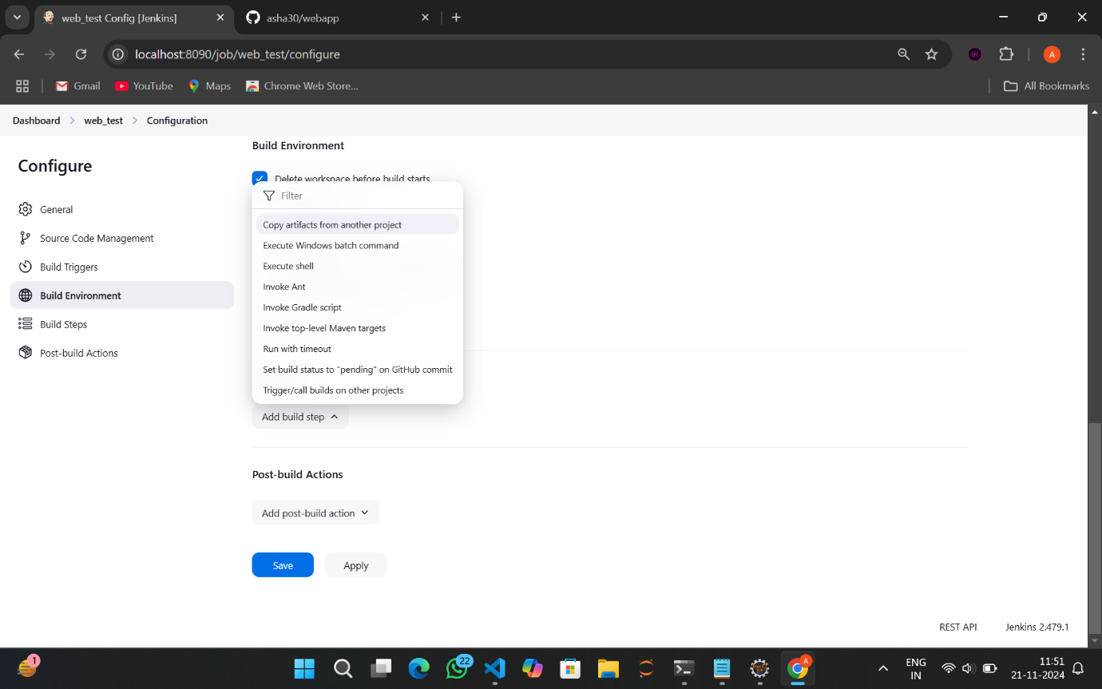

1. Here give project name as web_build and select Stable build only

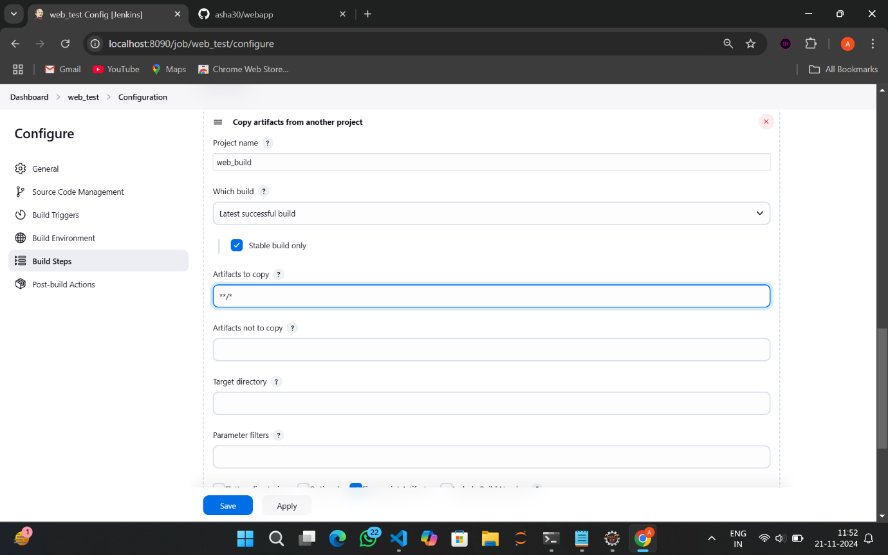

1. In artifacts to copy type **/*



1. Go to Add build step->Invoke top level maven targets

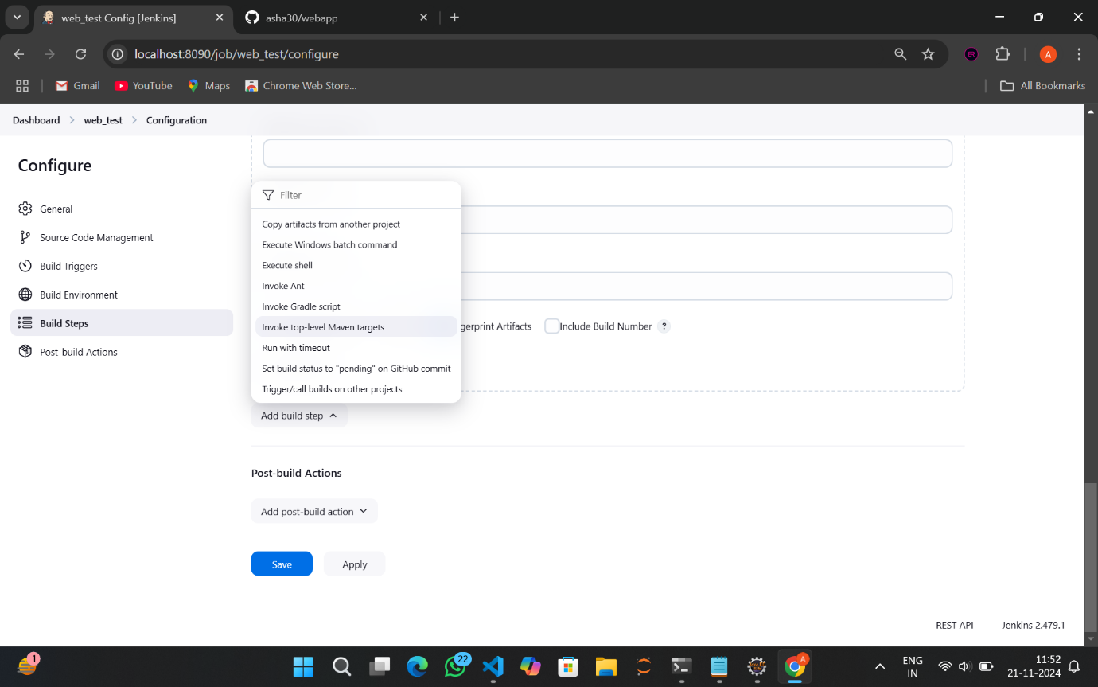

1. Give MAVEN_HOME path

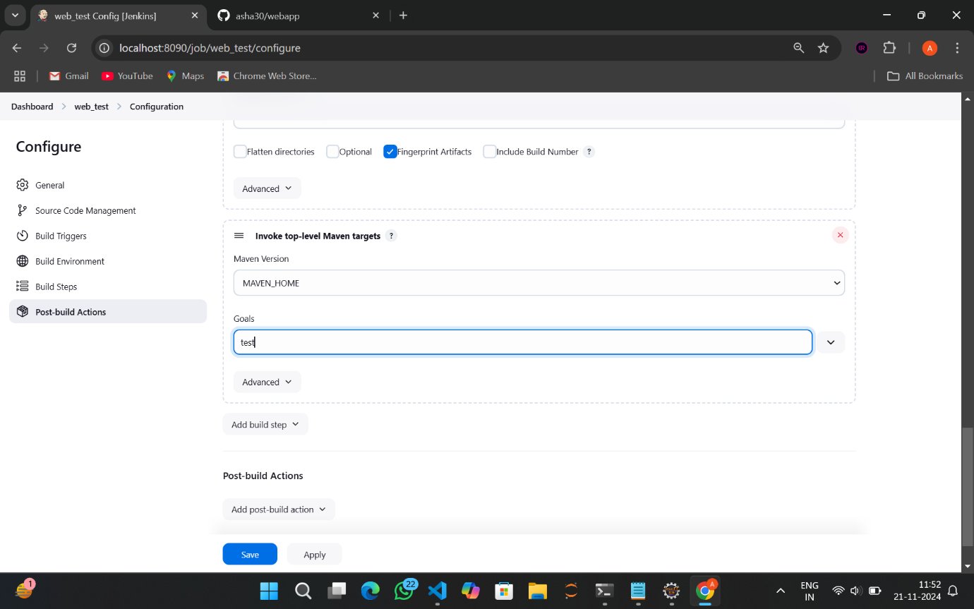

1. Give goals as test



1. Go to Add post-build action->Archive the artifacts

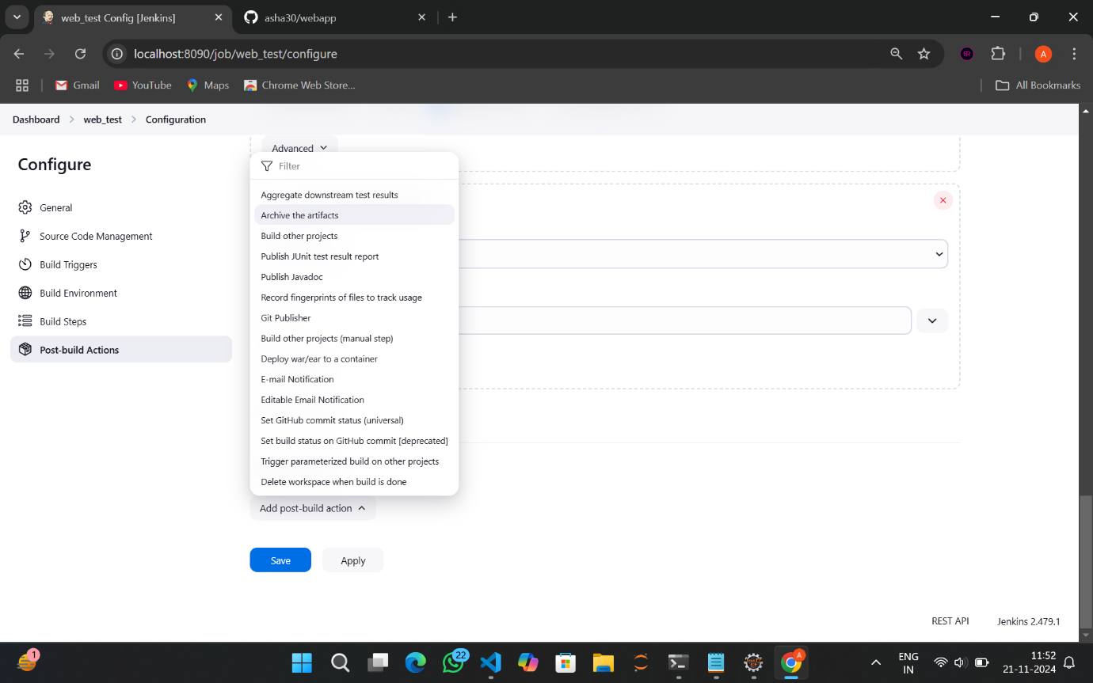

1. Give **/* as files to archive

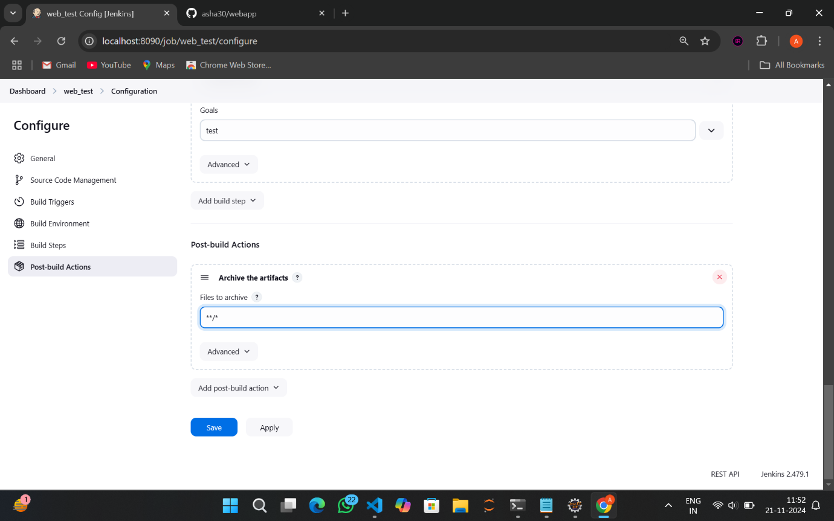

1. Go to Add post-build action->Build other projects

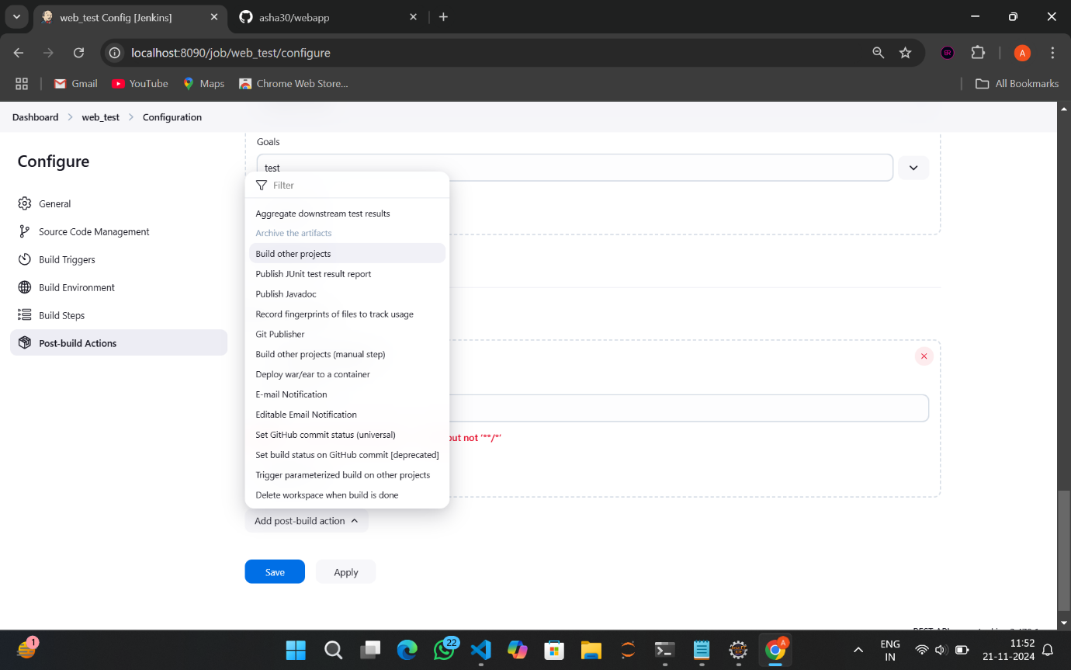

1. Give projects to build as web_deploy

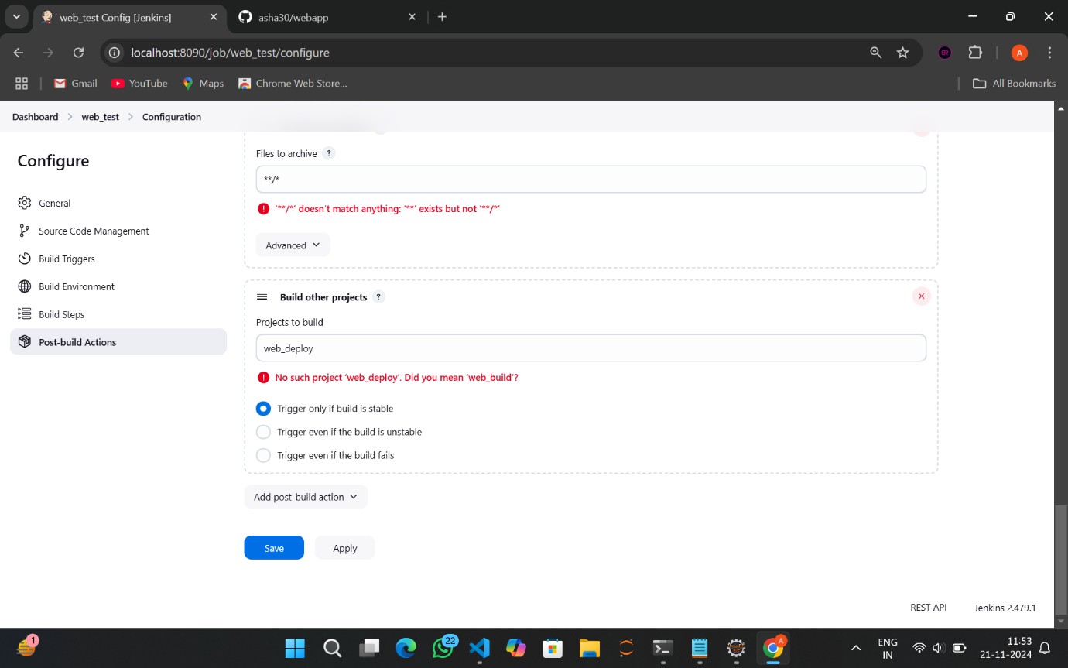

1. Click on Apply->Save
2. It was successful!!

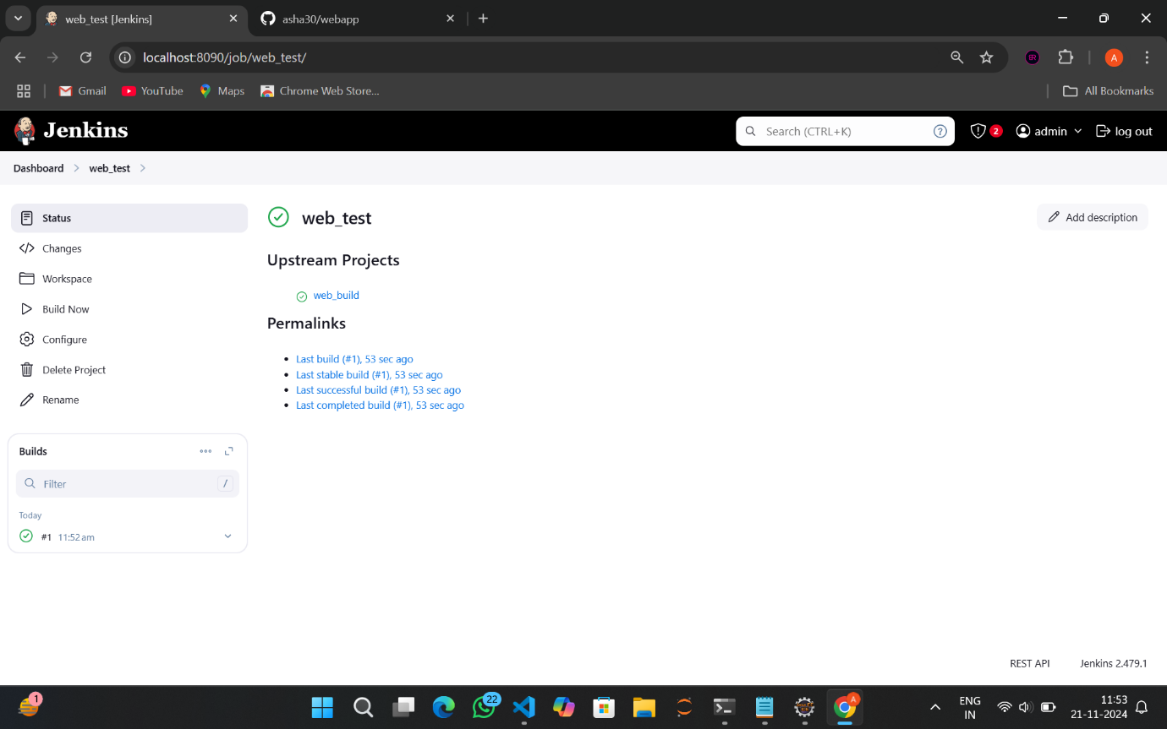

1. Go to dashboard->New Item

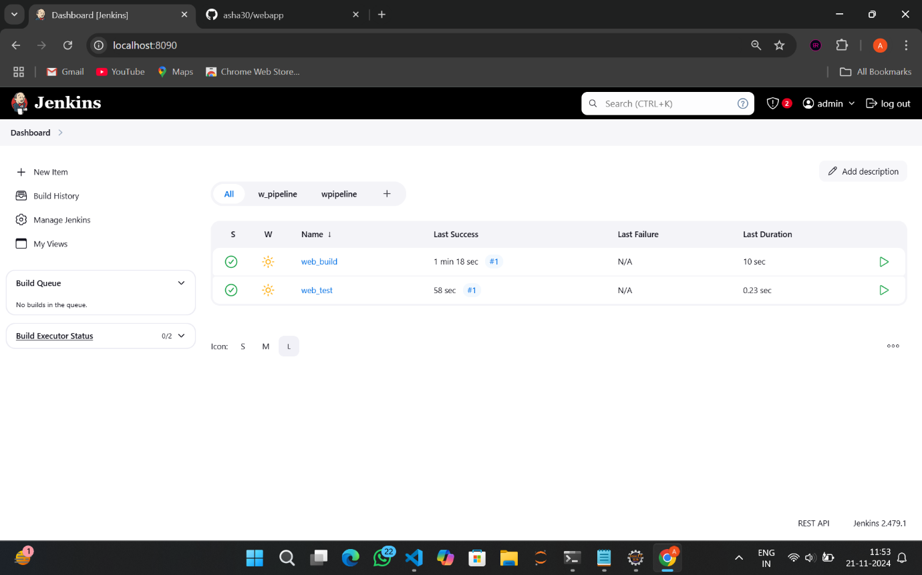

1. Give Item name as web_deploy ->Freestyle Project->OK

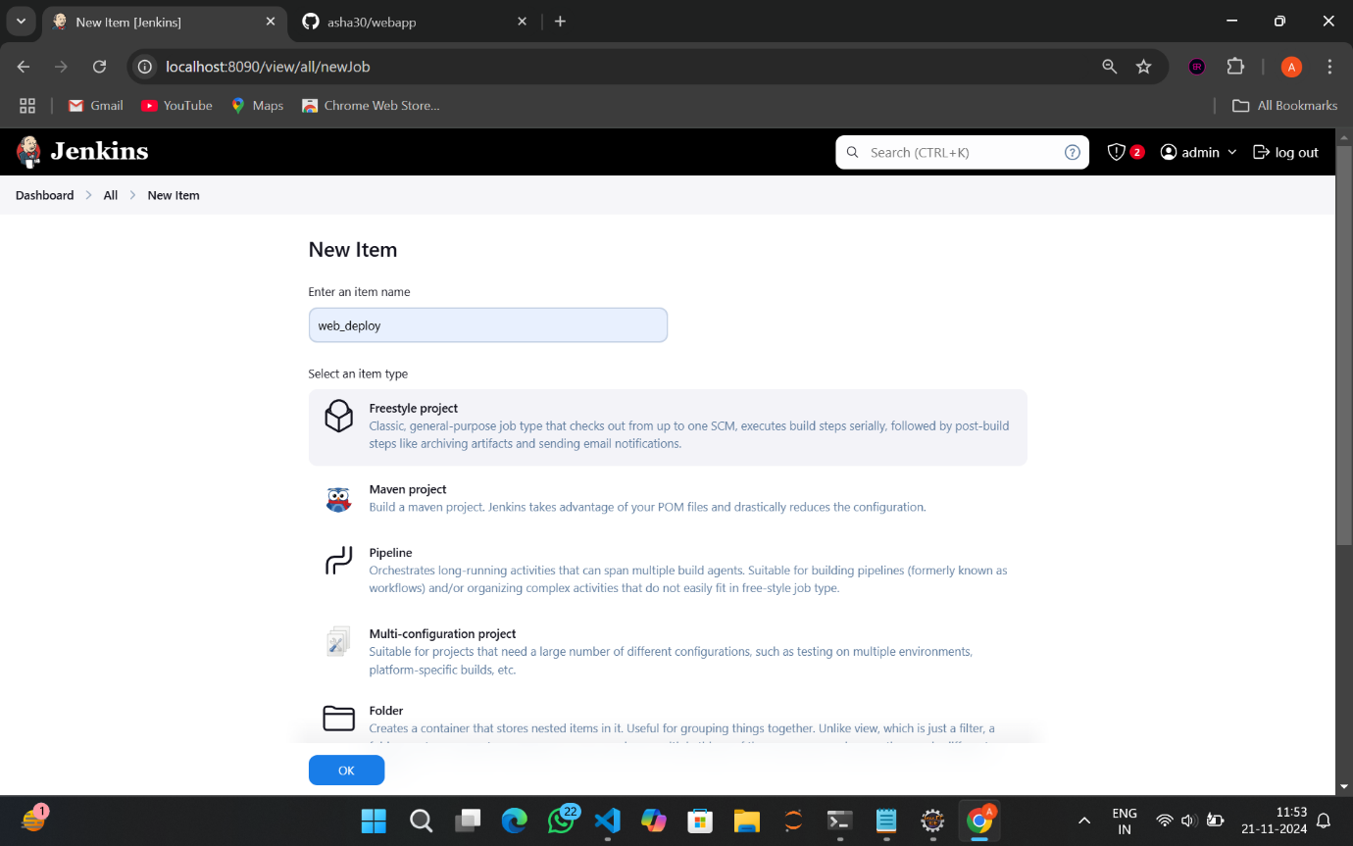

1. Go to build environment and select Delete workspace before build starts

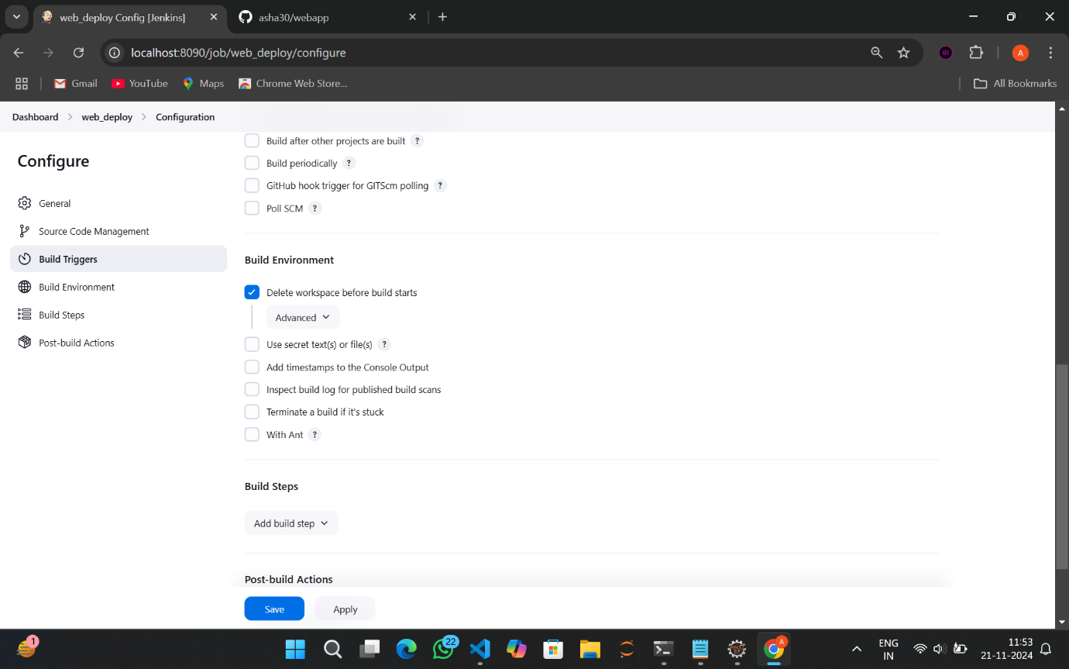

1. Click on Add build step->Copy artifacts from another project

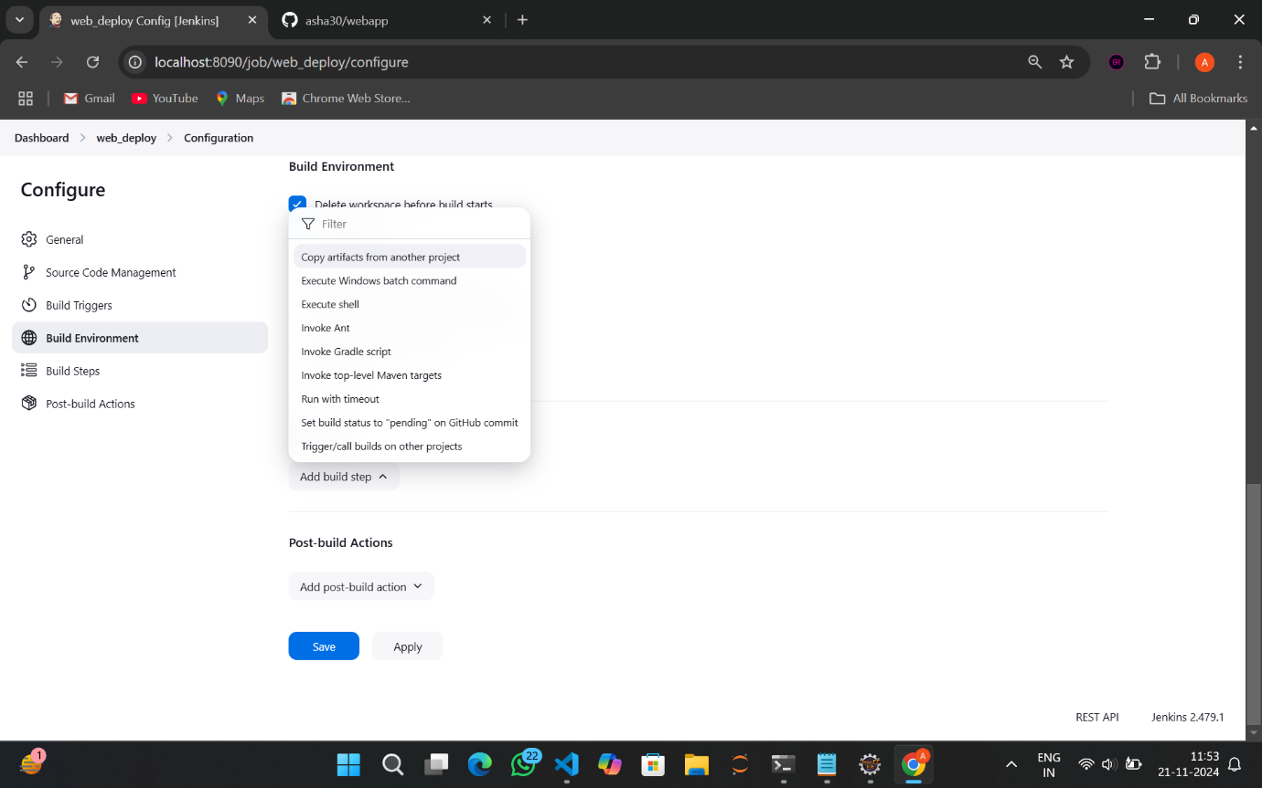

1. Give Project name as web_test, Select stable build only and give **/* as Artifacts to copy

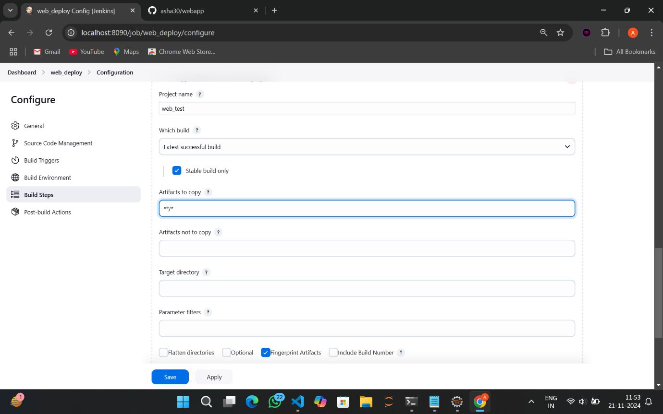

1. Go to Add post-build action->Deploy war/ear to a container

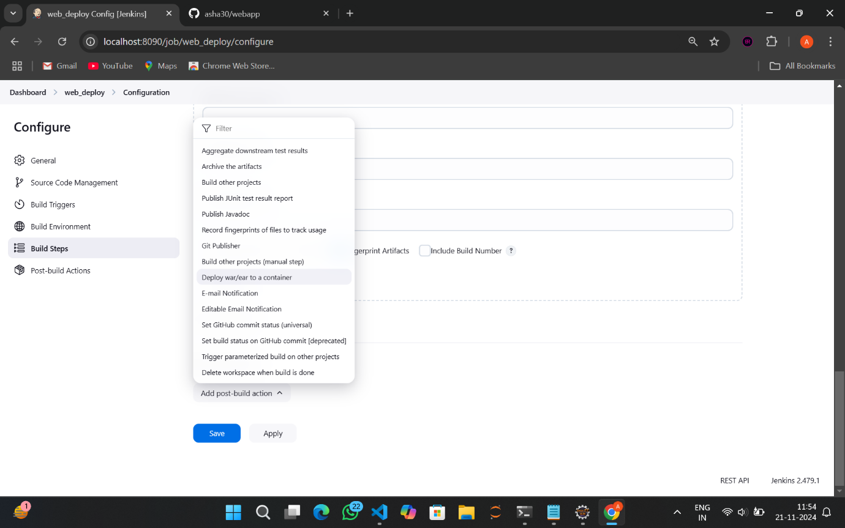

1. Give **/*.war as war/ear files and context path as webpro2

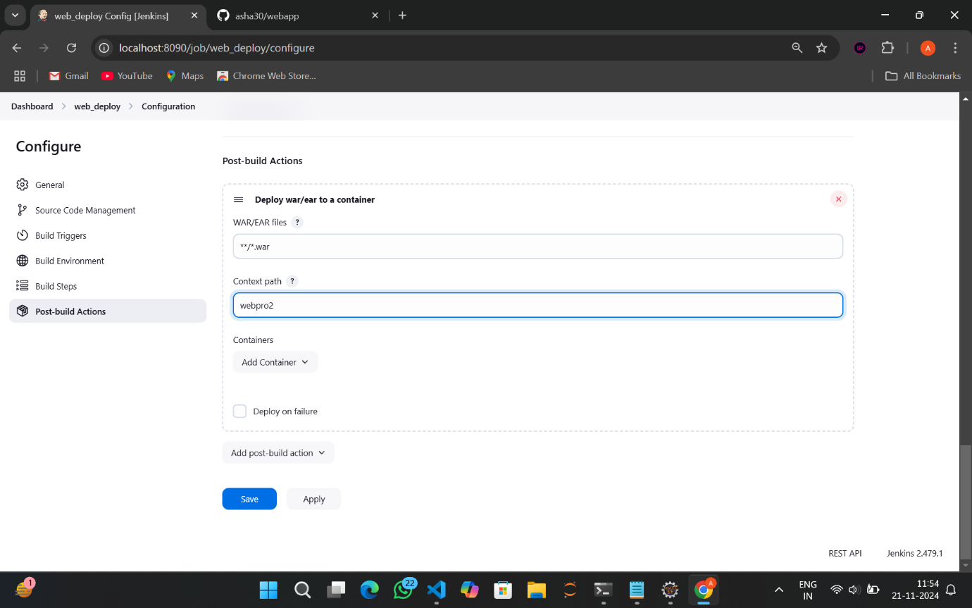

1. Go to Add container->Tomact 9x Remote

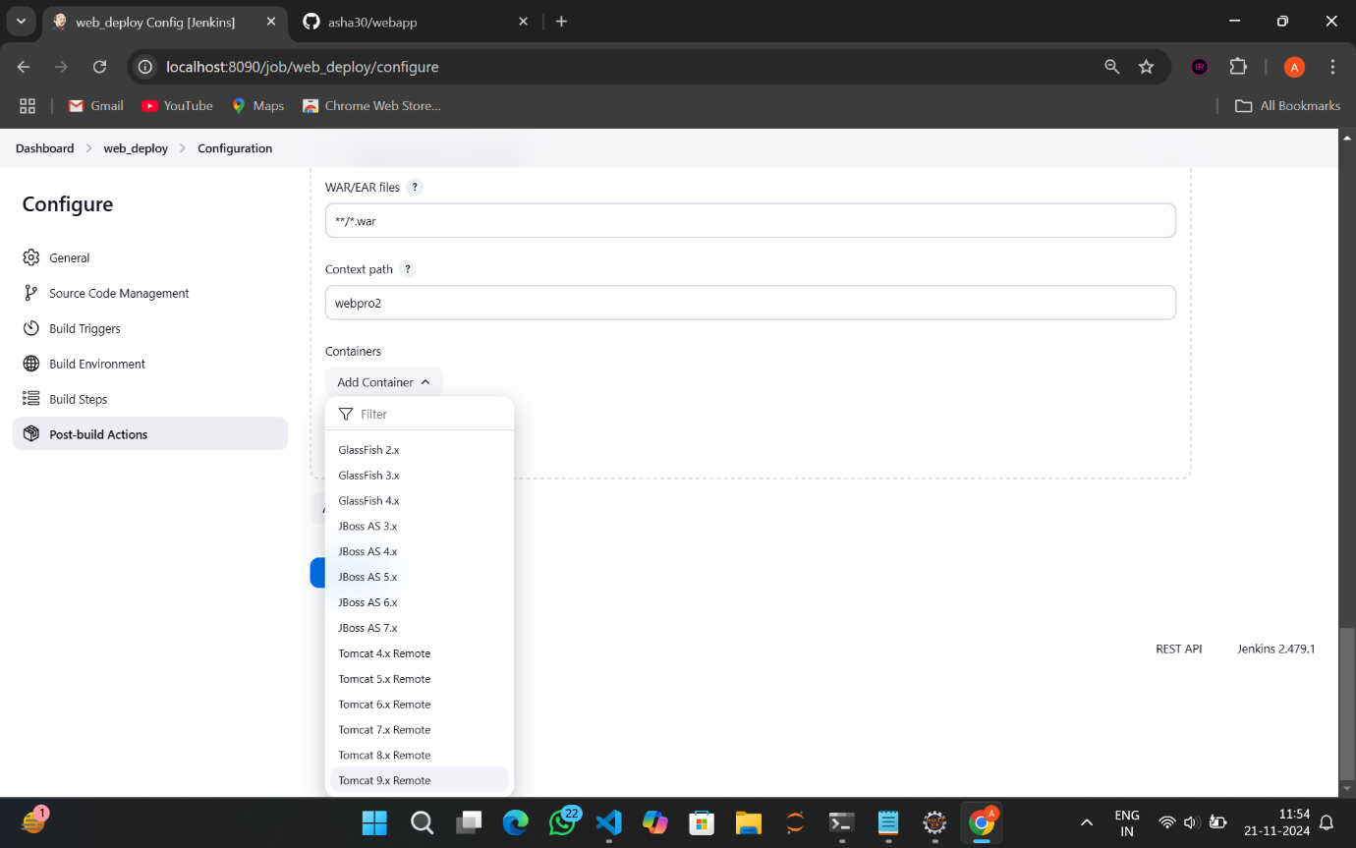

1. Under Credentials Click Add

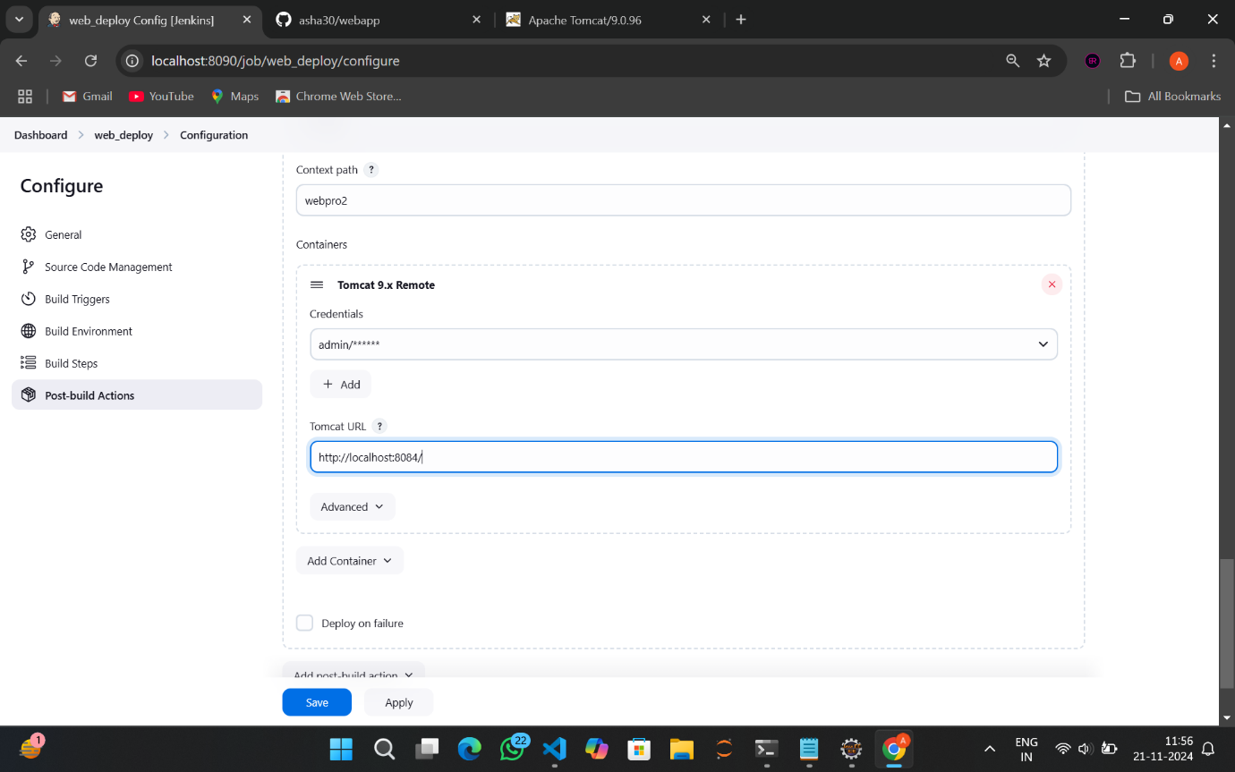

1. Select Jenkins Credential provider
2. Here give your username and password

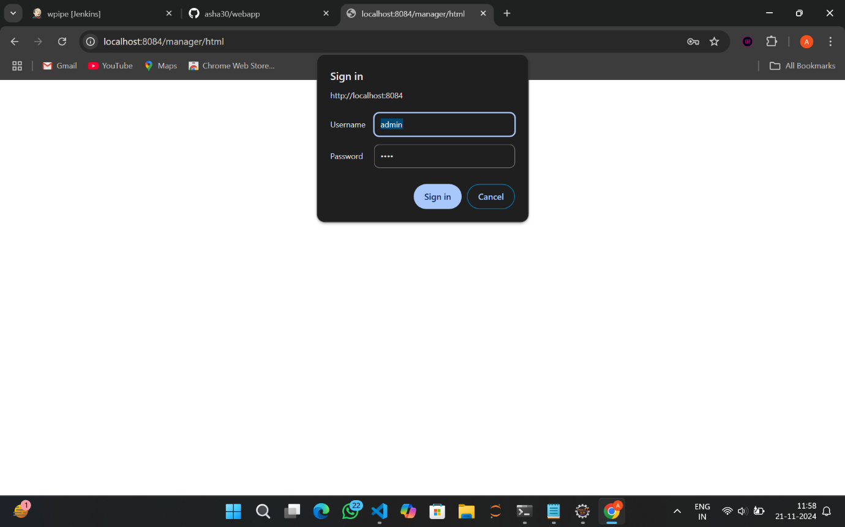

1. Click on Add
2. Give your tomcat url



1. Under credentials select your added credential

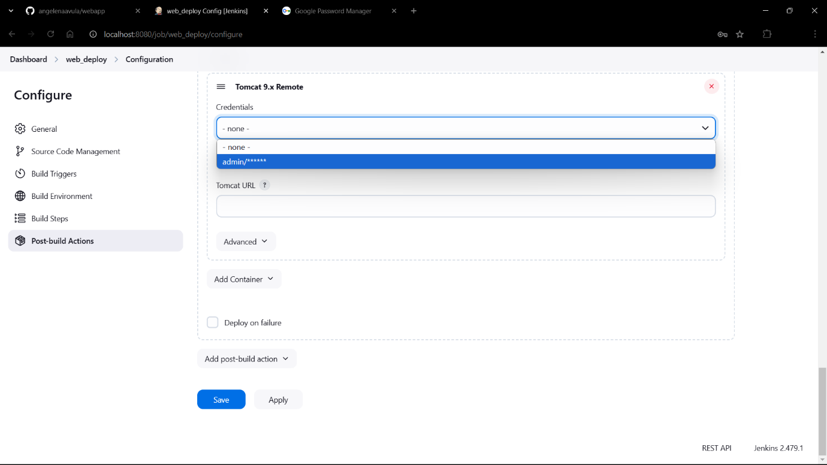

1. Copy your tomcat url

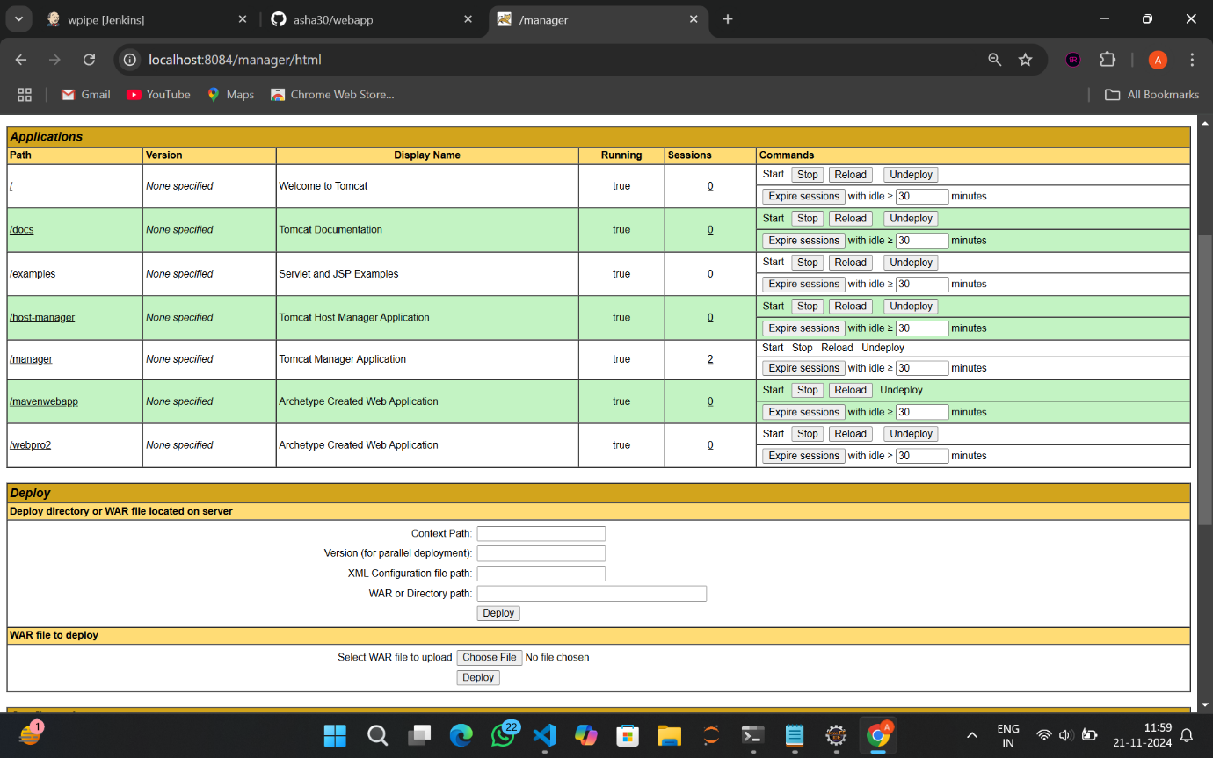

1. Paste it under Tomact url

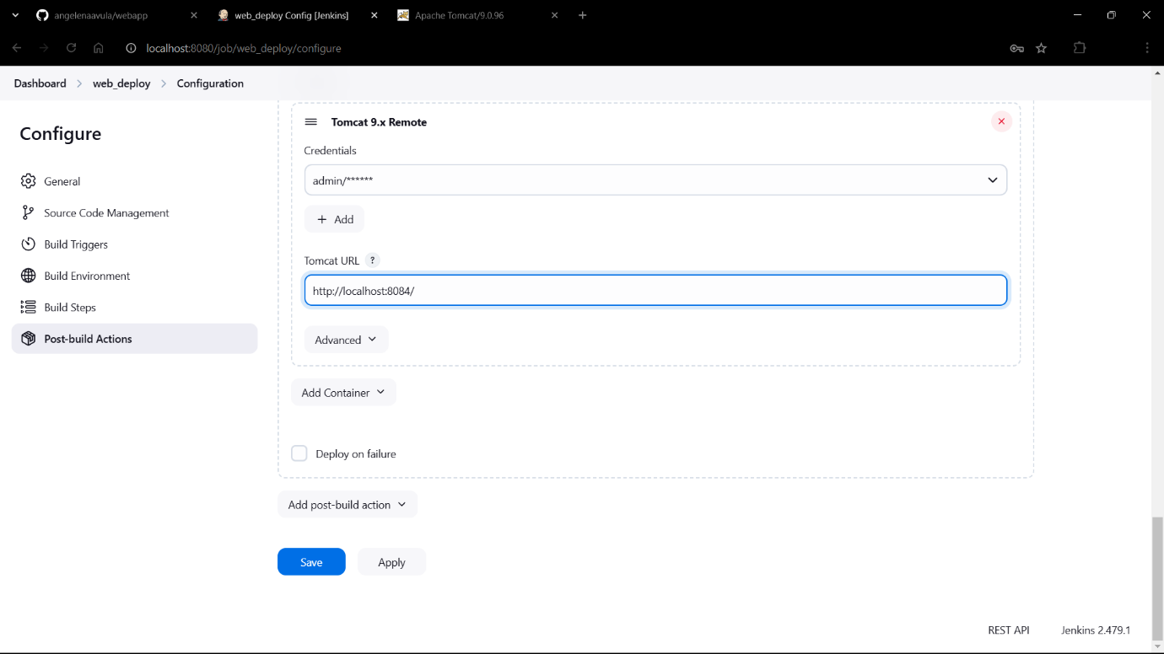

1. Click on Apply->Save

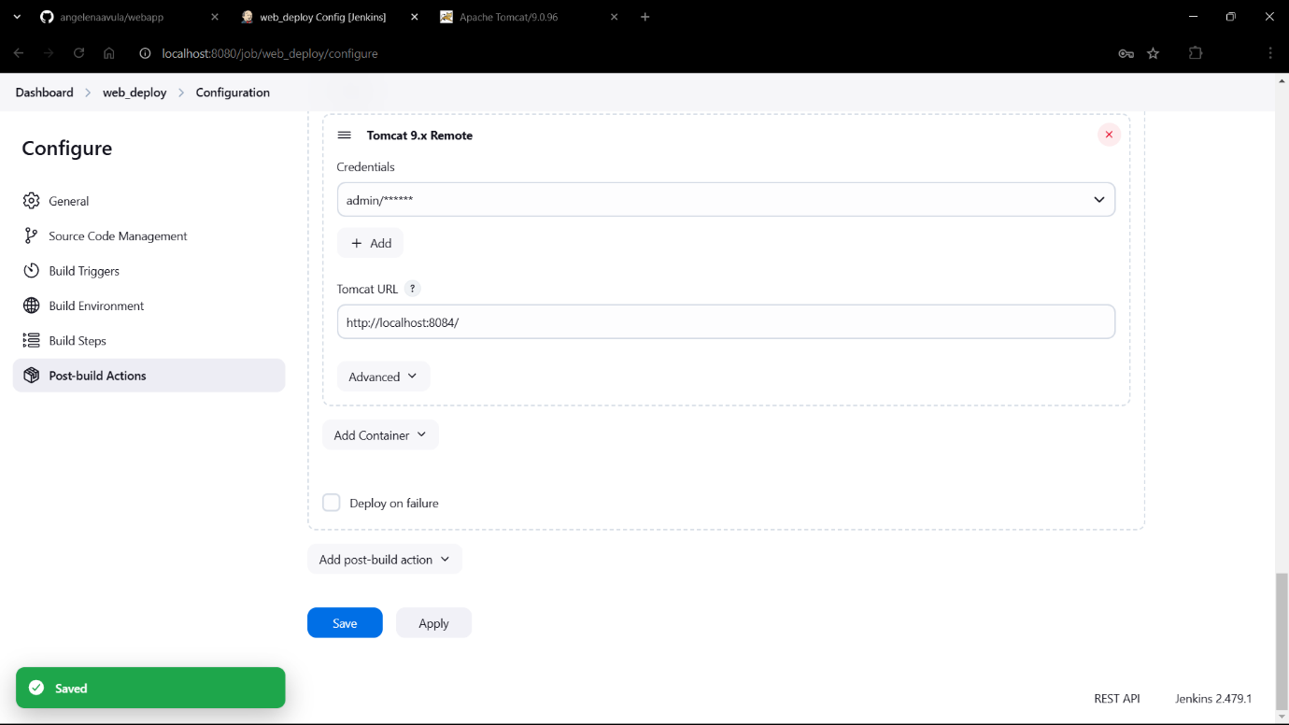

1. Web_deploy was successful!!

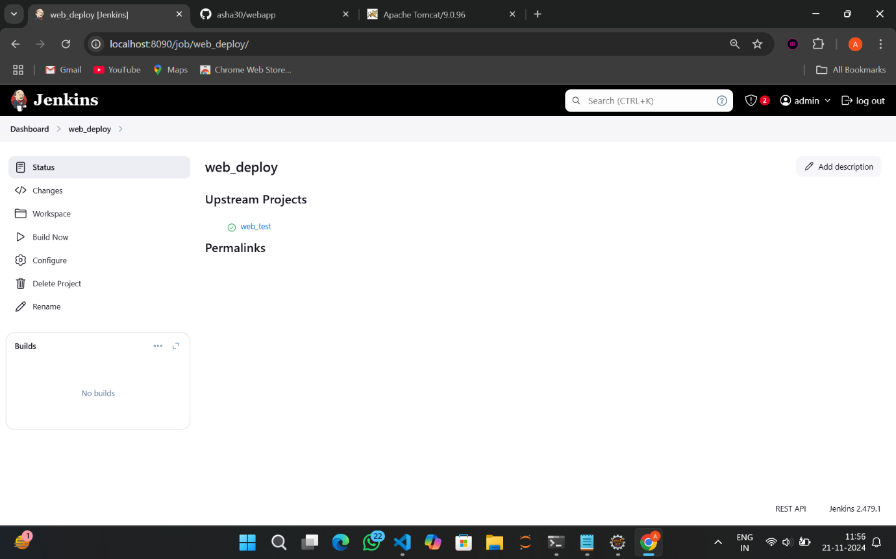

1. Go to Dashboard->New View (the + icon)

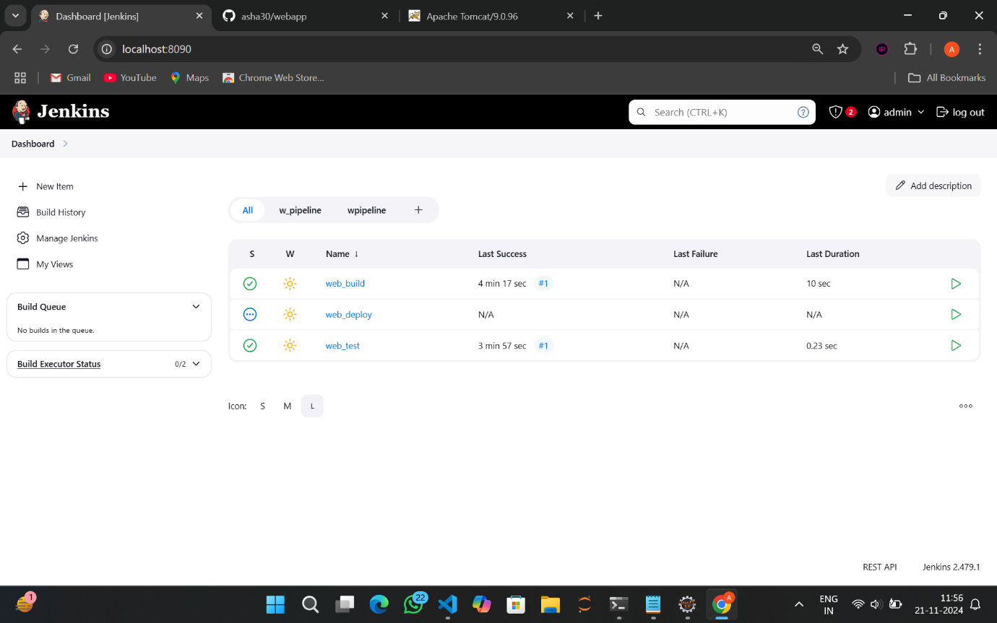

1. Give name as w_pipeline and select type as Build Pipeline View->Create

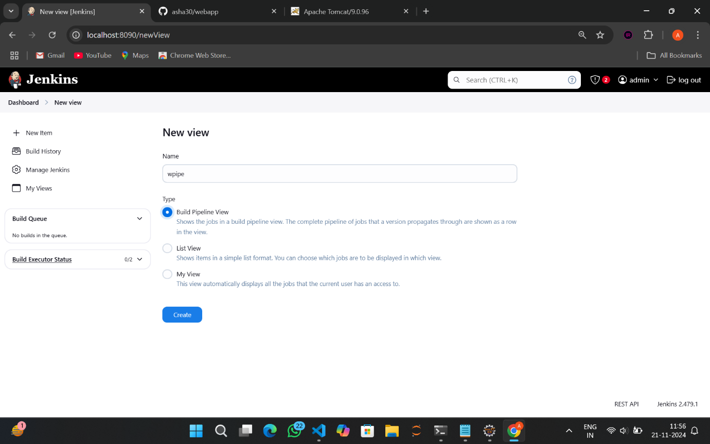

1. Scroll down

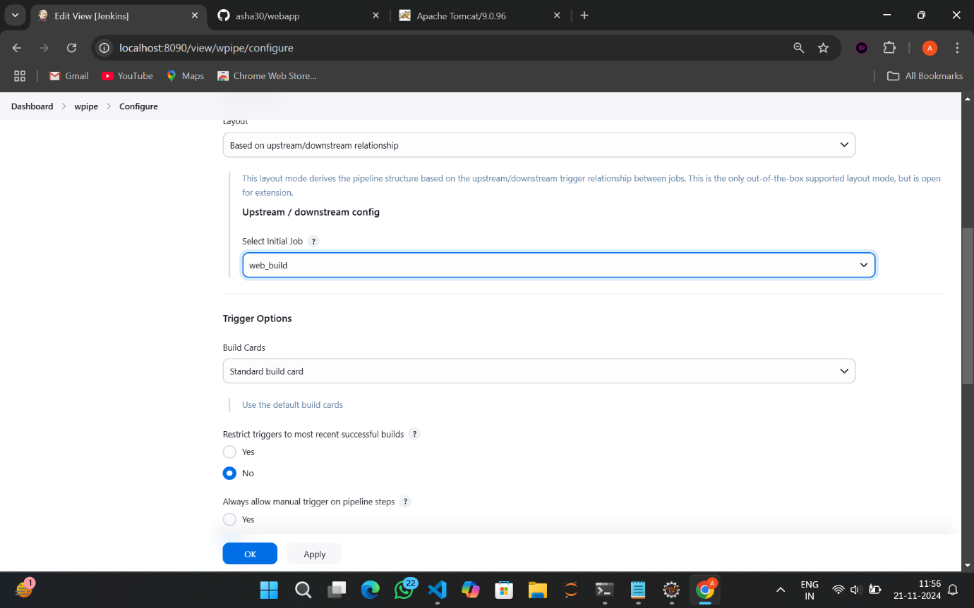

1. Here select initial job as web_build

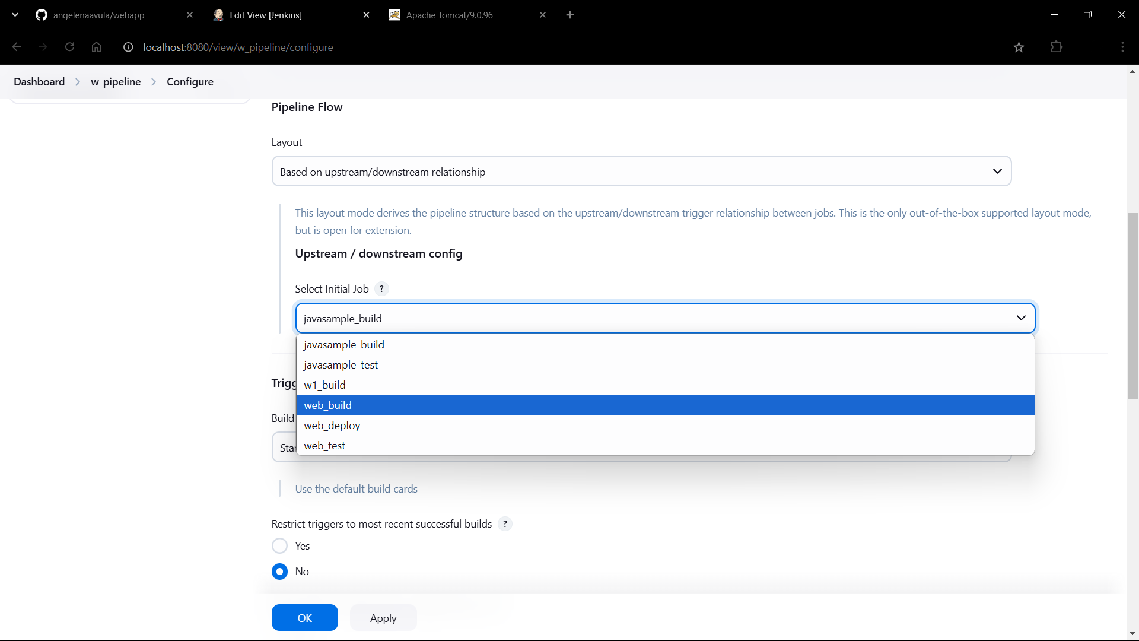

1. Scroll down and Click OK

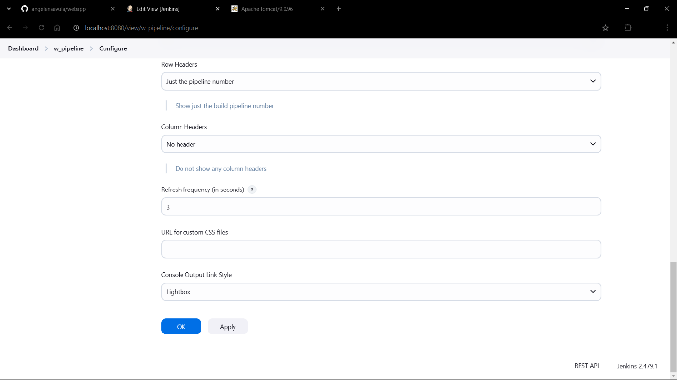

1. Wait unti yellow turns green, run the web_test, Run the web_deploy
2. We can see that all have turned green and it is successful!!!

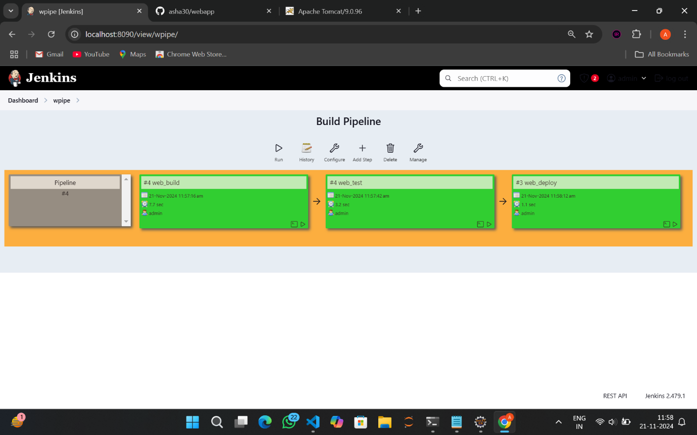

1. In your tomcat port navigate to /manager and Sign in with credentials



1. You will see this page after successful login

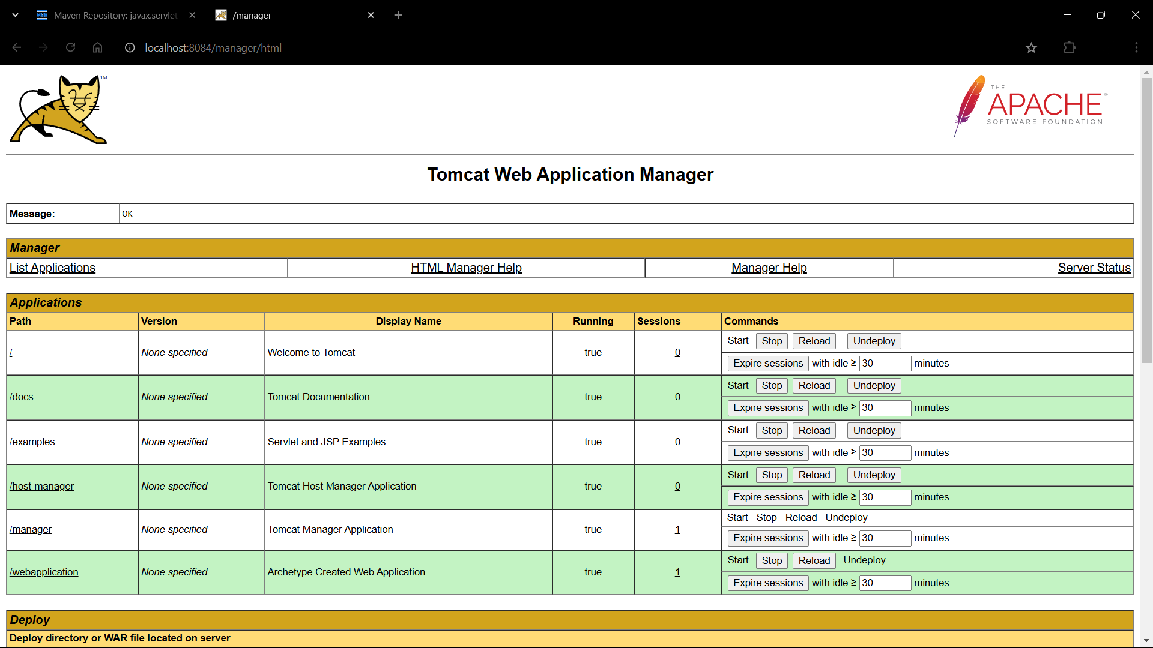

1. Scroll down and you will find /webpro2

Click on it



1. The hello world message is being displayed

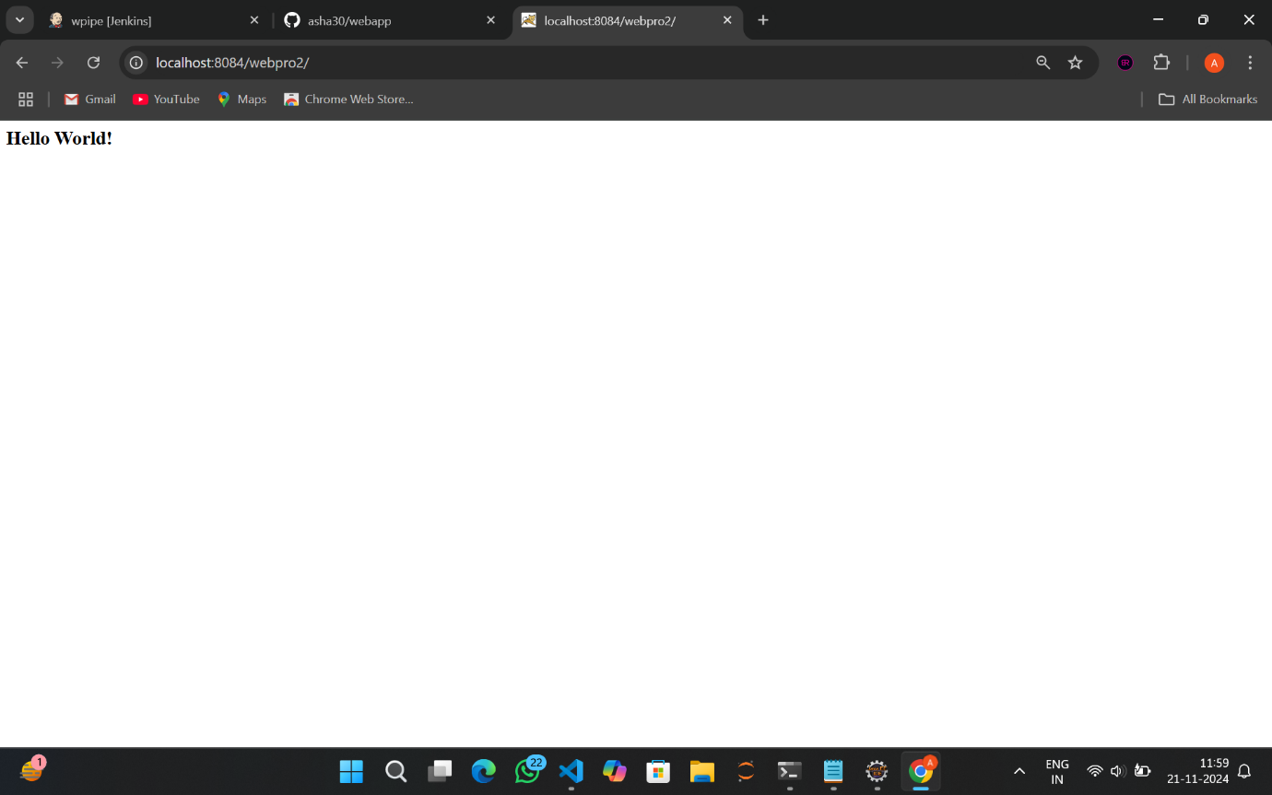

1. Now go to your webapp repository and open scr->main->webapp->index.jsp

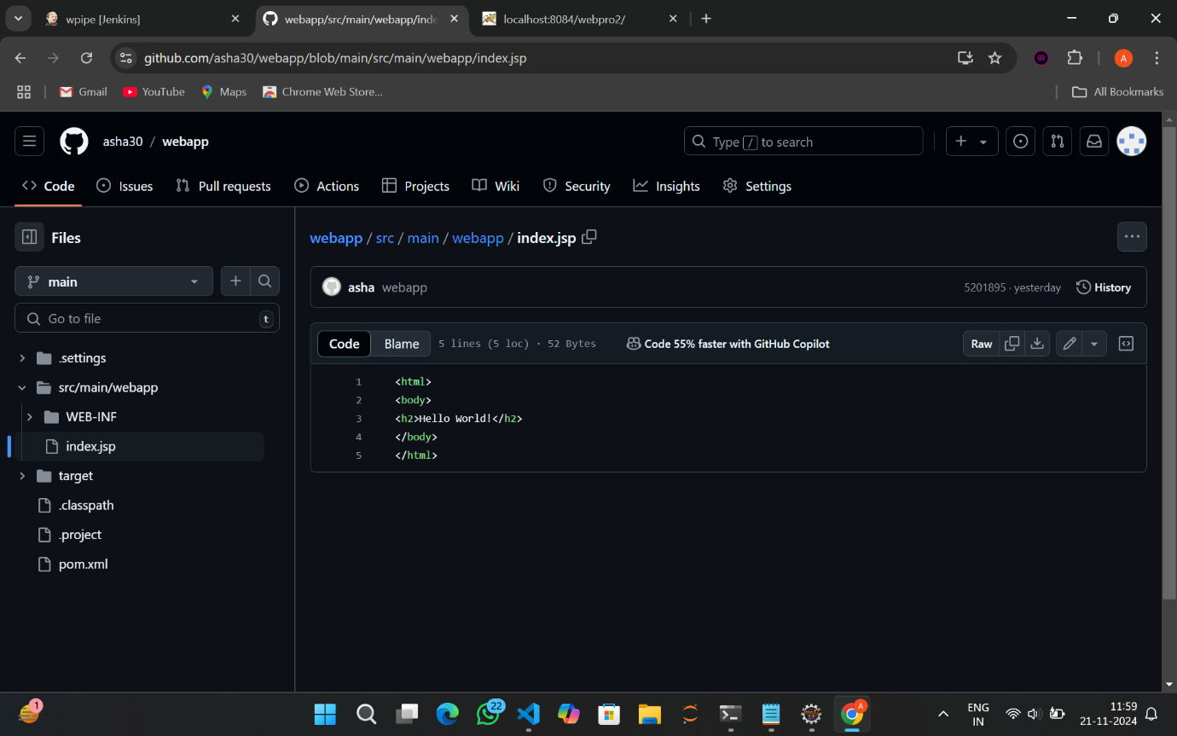

1. Here make changes to your index.jsp file like adding a few more headings as shown

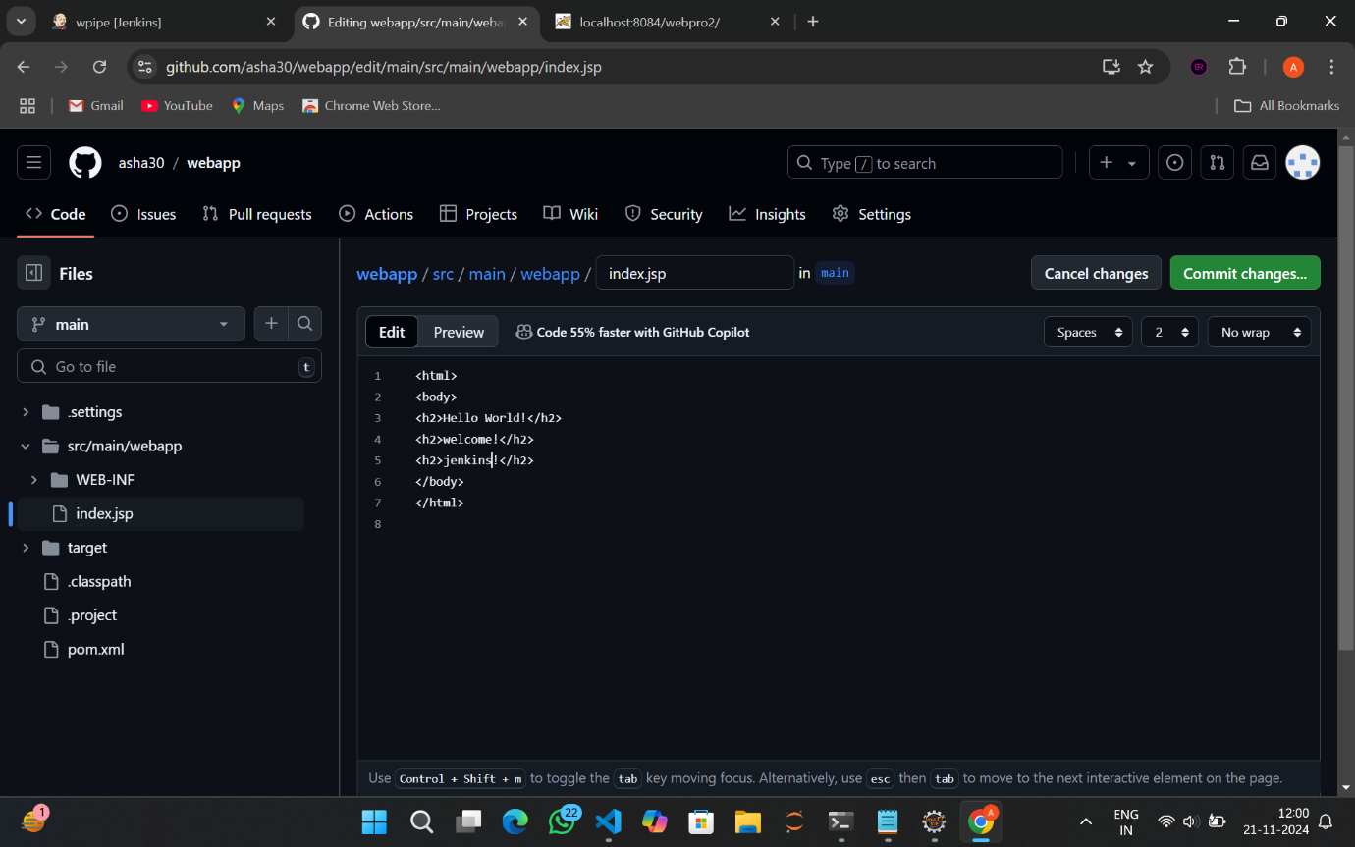

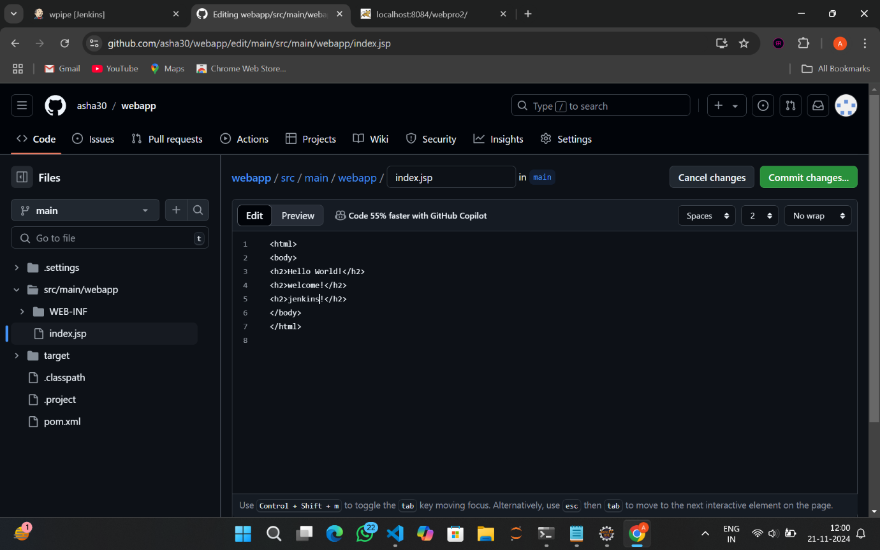

1. Click on Commit changes->Commit changes

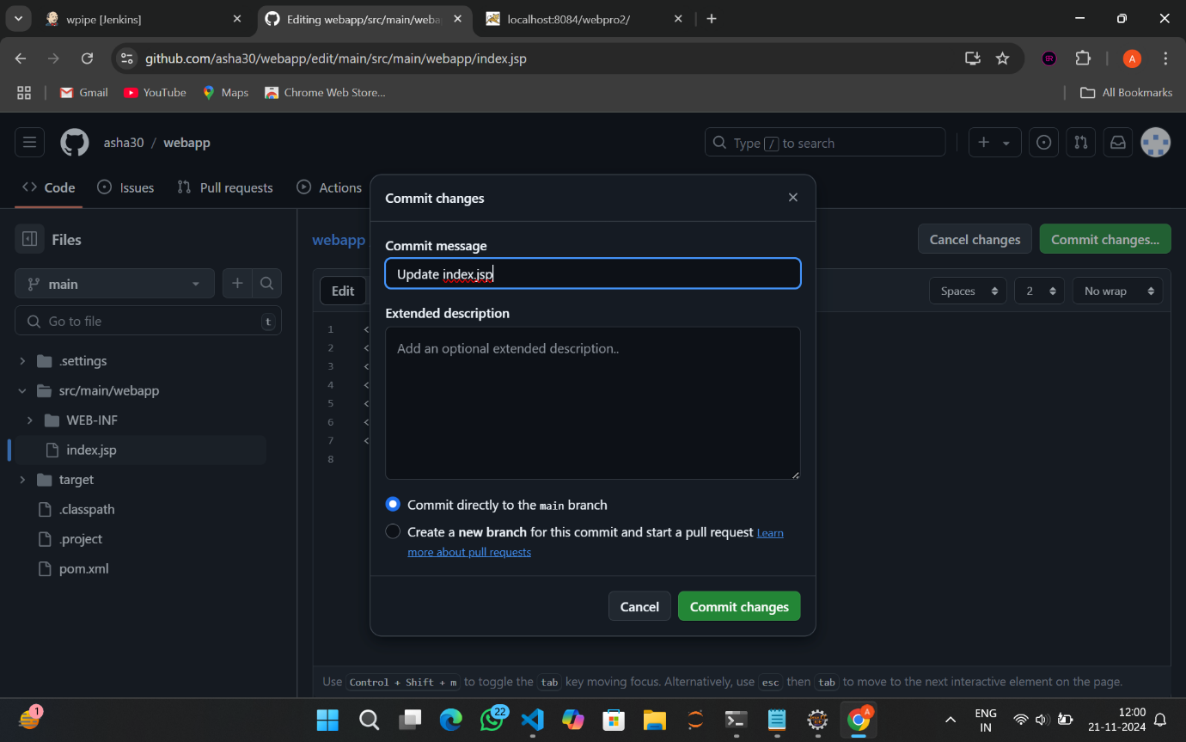

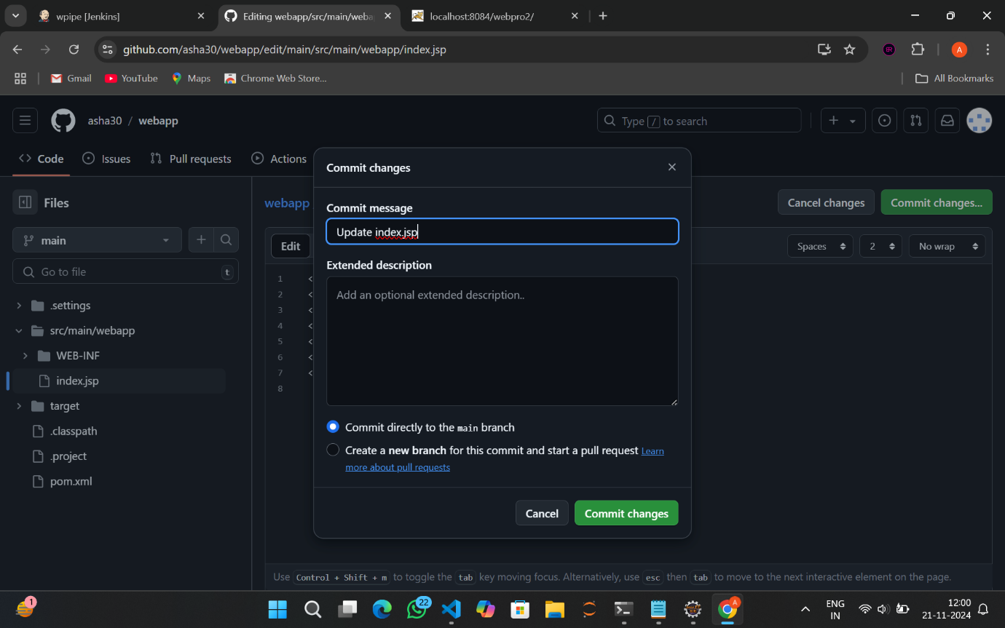

1. The update was successful!!

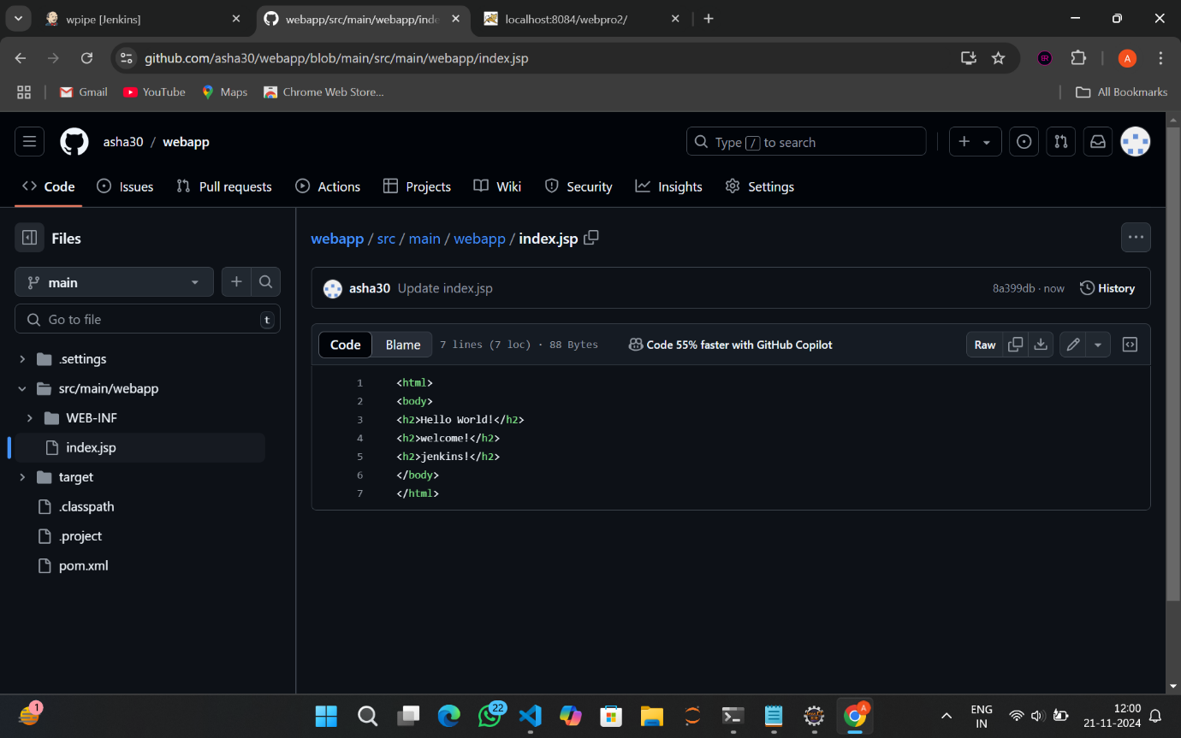

1. Now go to Jenkins dashboard and click w_pipeline
2. Click on Run

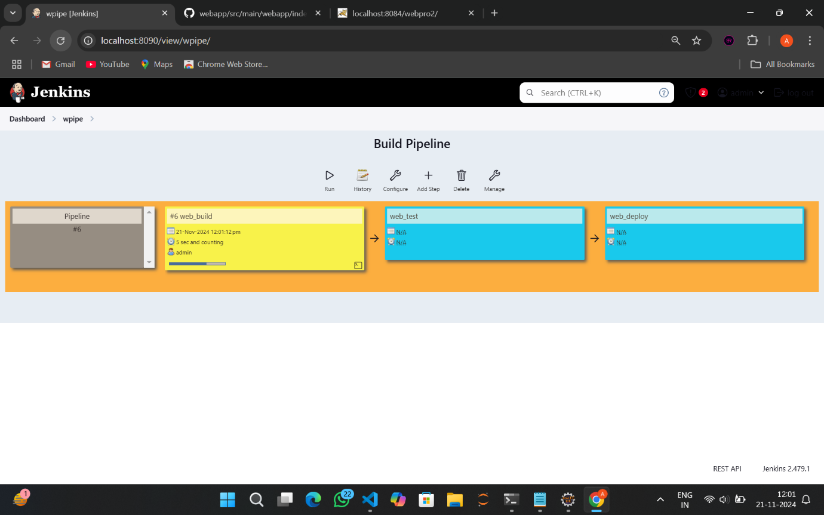

1. Wait till they all change green
2. Run the web_test

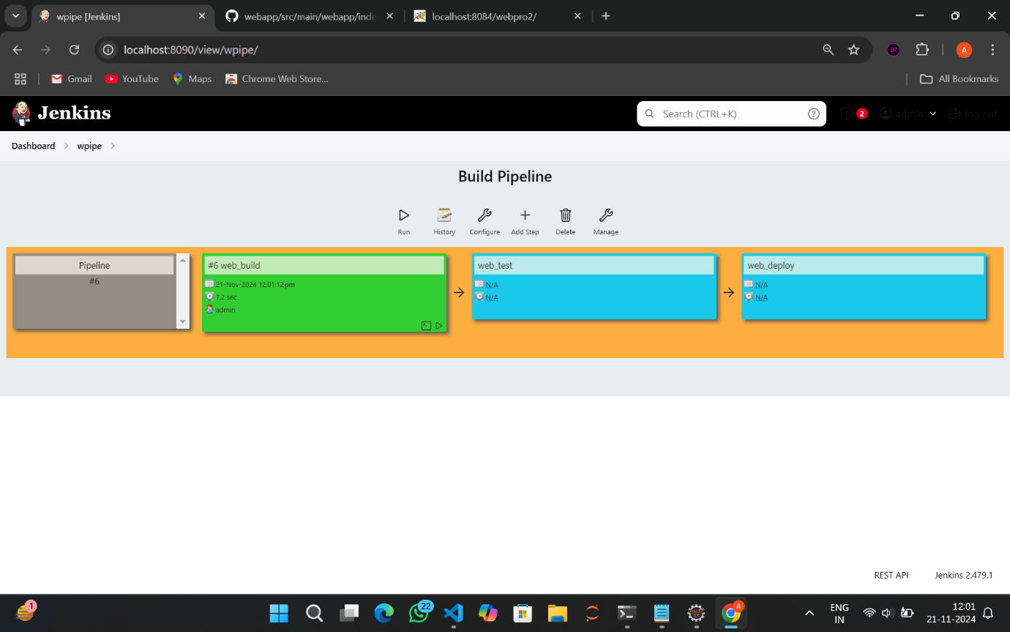

1. Run the web_deploy and wait till it changes to green



1. It was successful!!

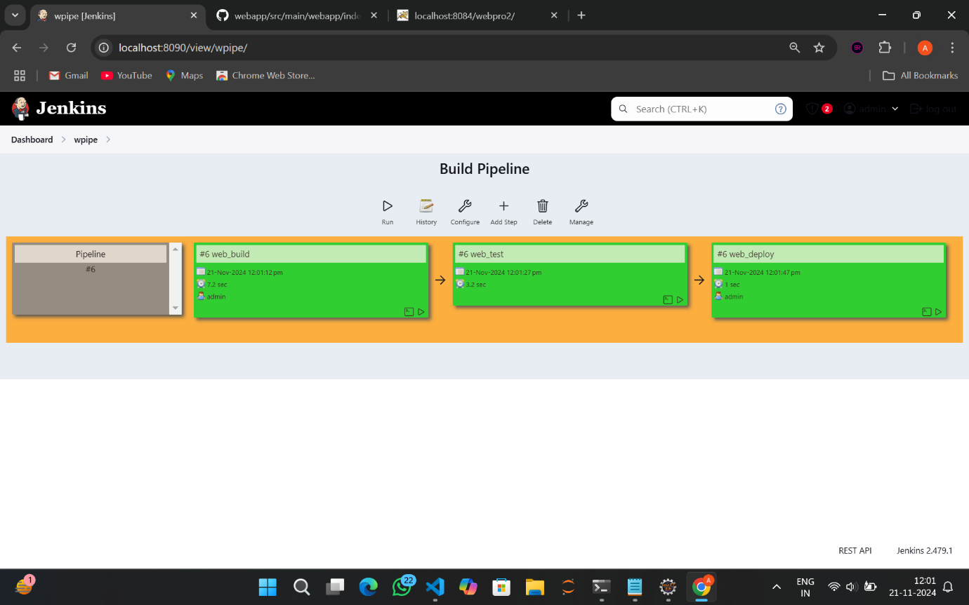

1. Go to your tomcat port and refresh the page

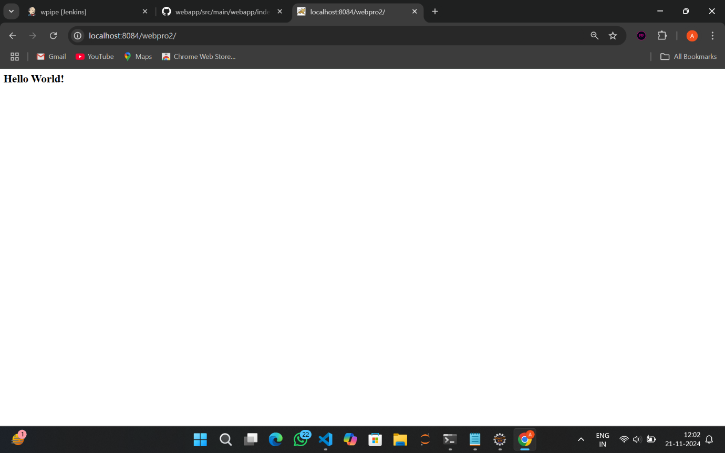

1. You can see the changes made to the index.jsp on the port.

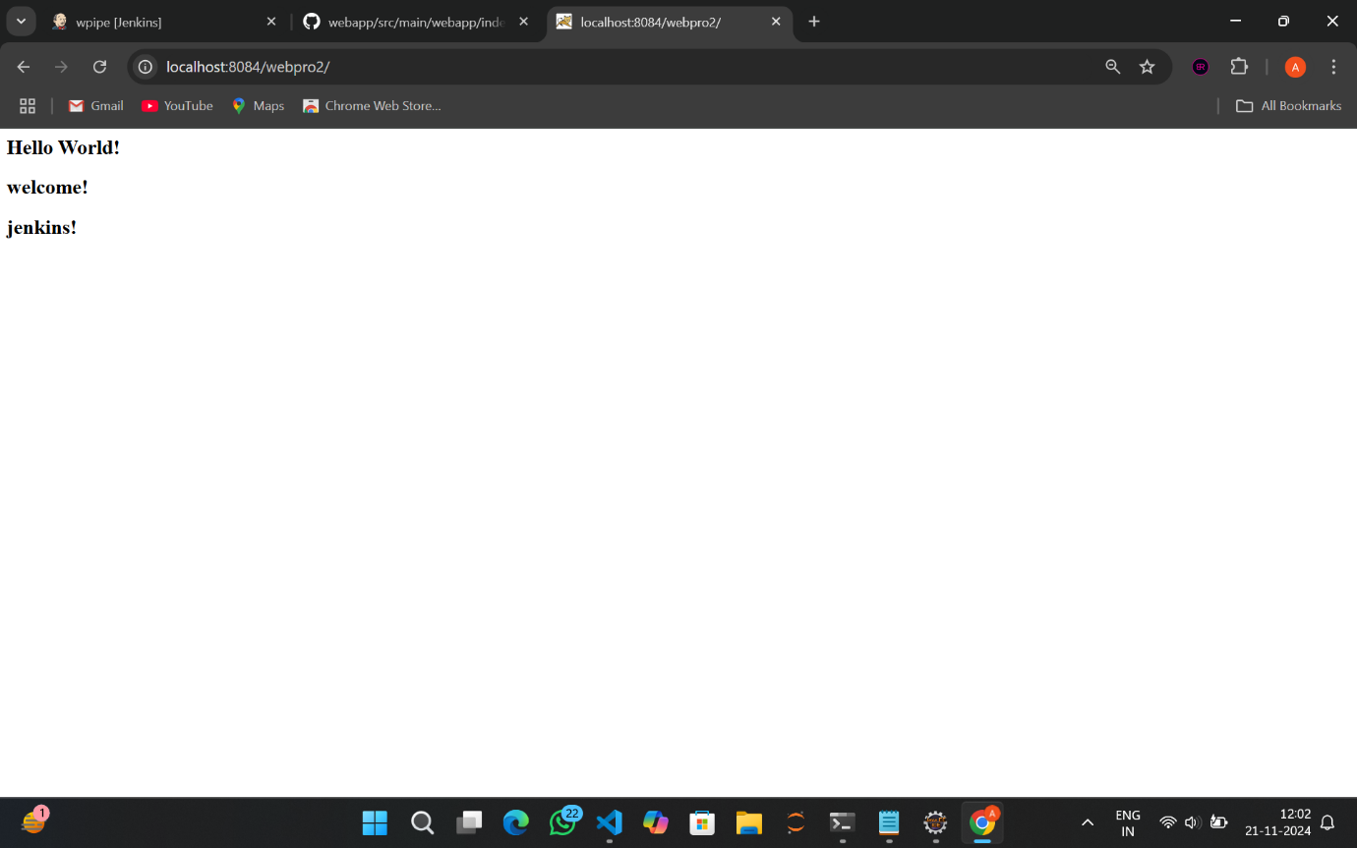

AND THE PROCESS IS DONE!!!

JENKINS SCRIPT PIPELINE

1.open manage Jenkins page and click on plugins

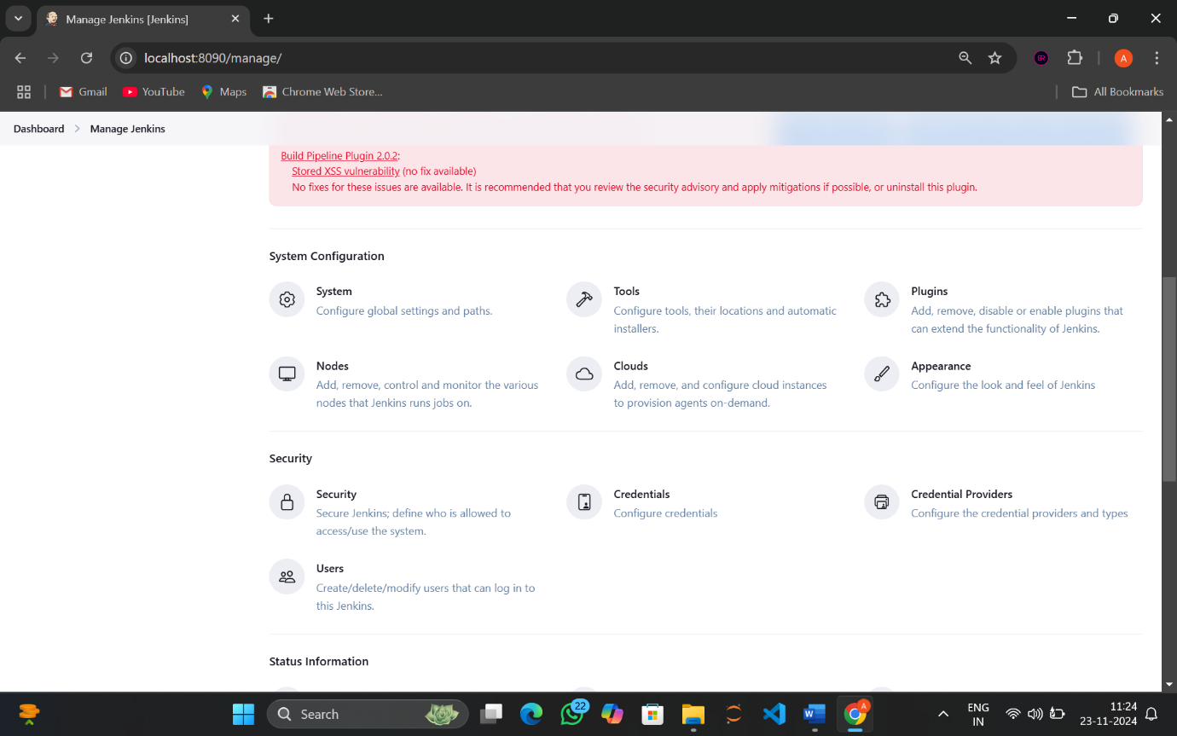

2.select available plugins and search for pipeline stage view

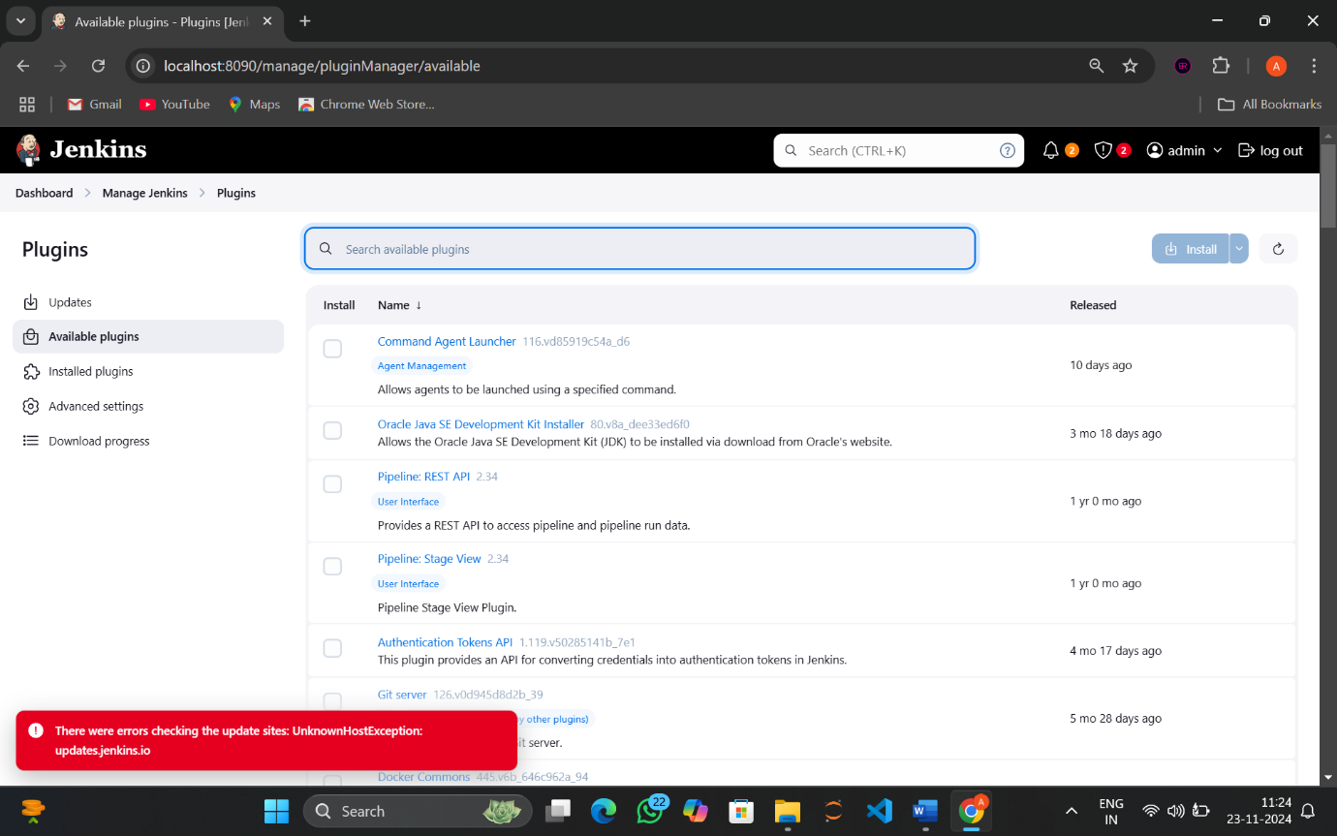

3.select stage view and install

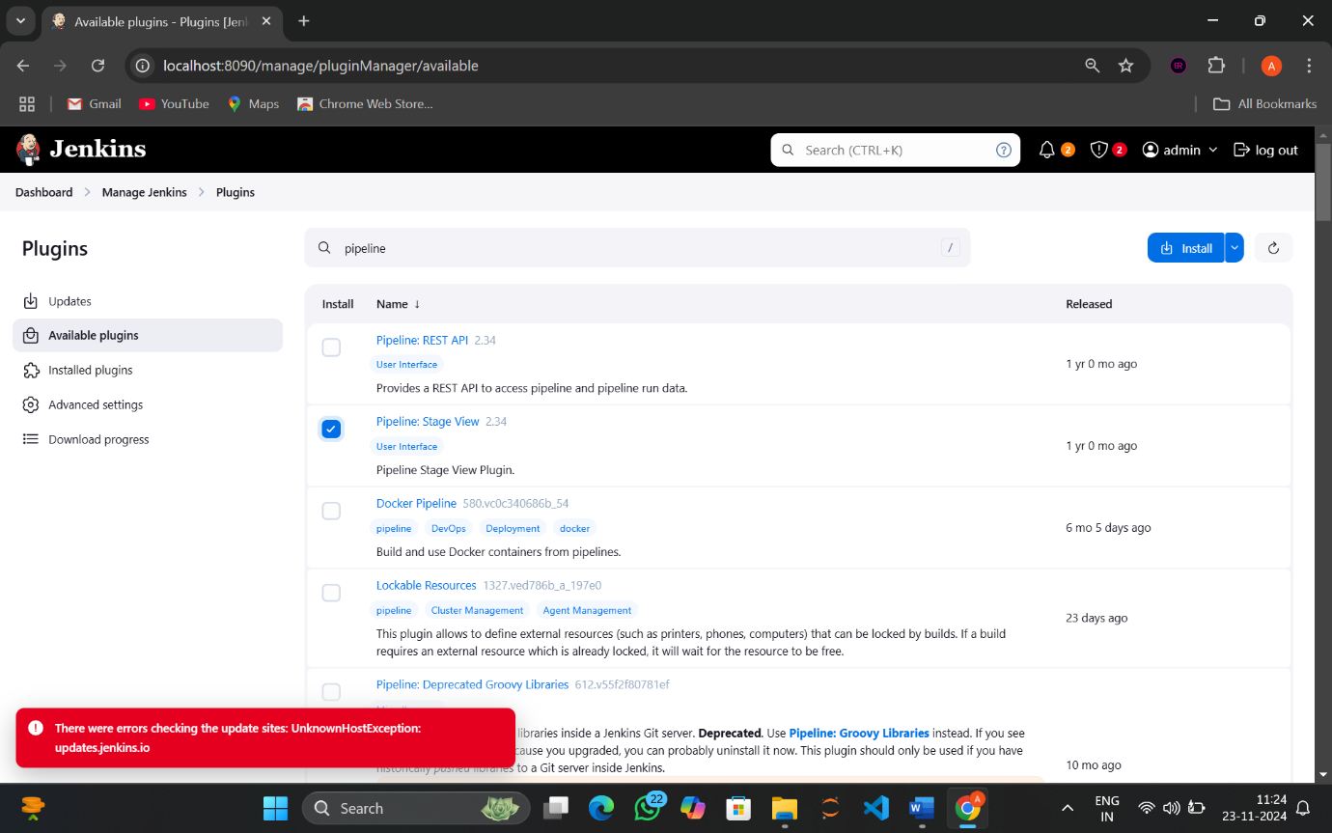

4.now the stage view is installing..

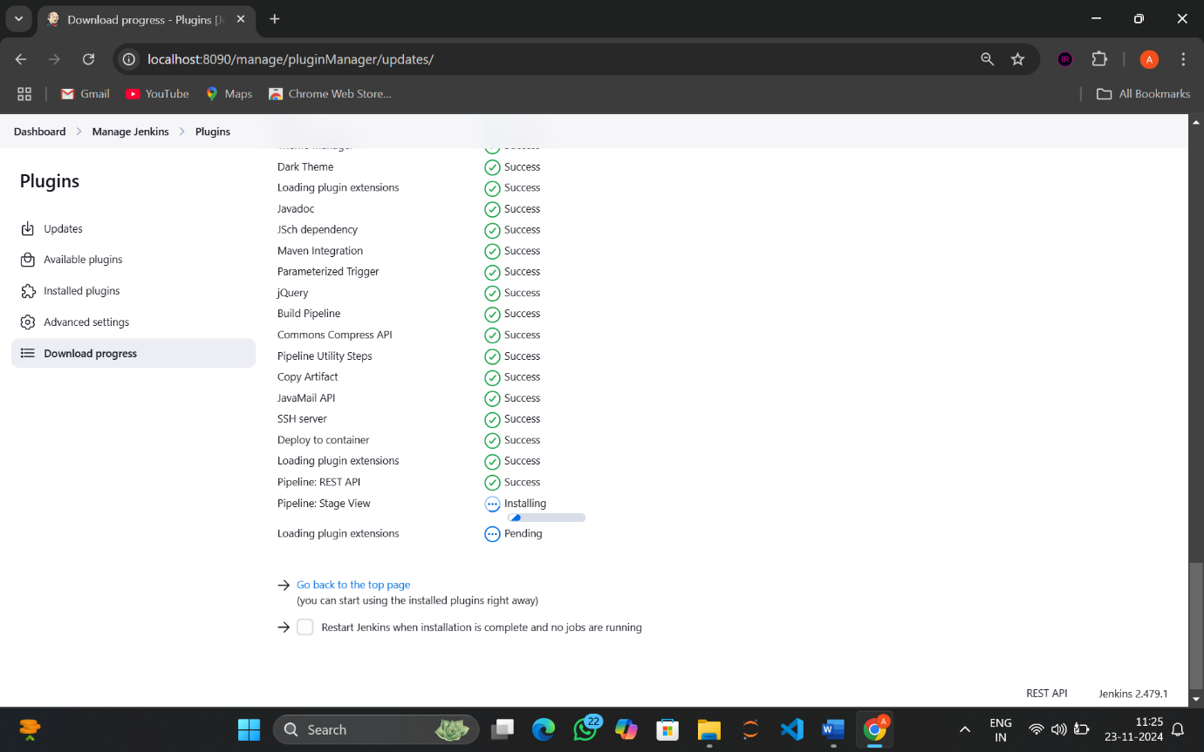

5.successfully installed!!

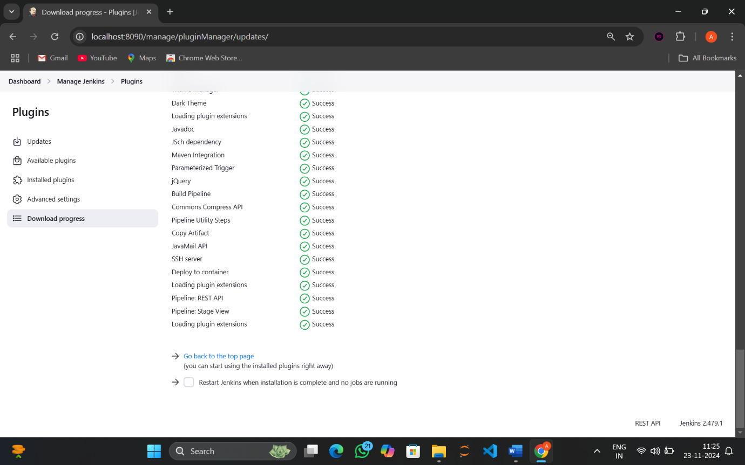

6.now select new item and give name as script_pipe

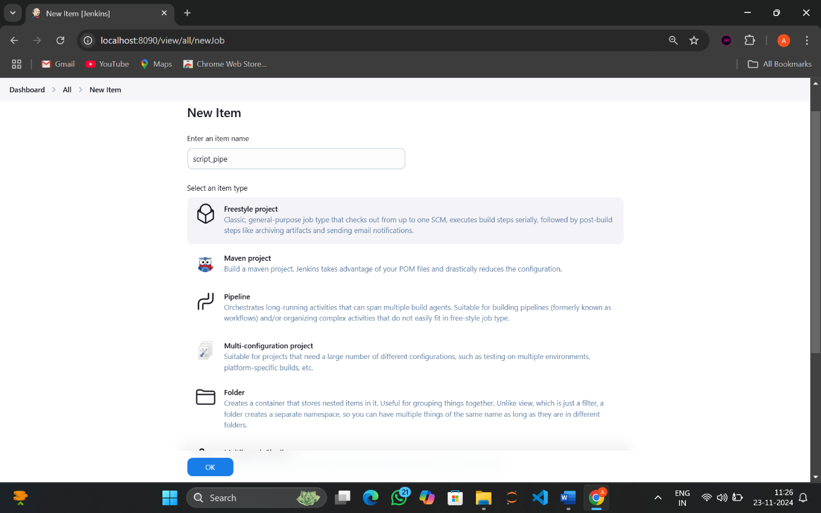

7.select an item type as pipeline and click on ok

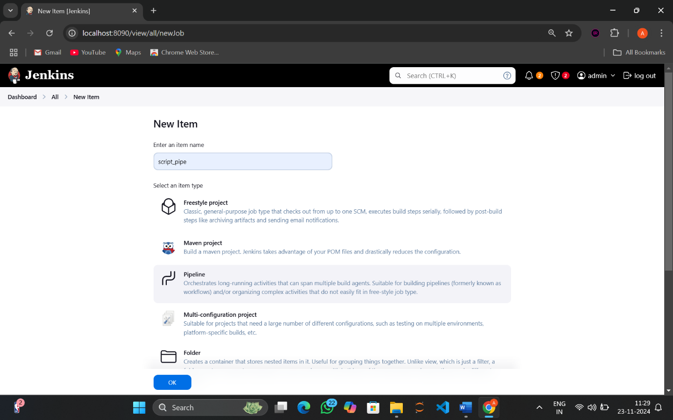

8.now configure page is open , go to advanced project options..

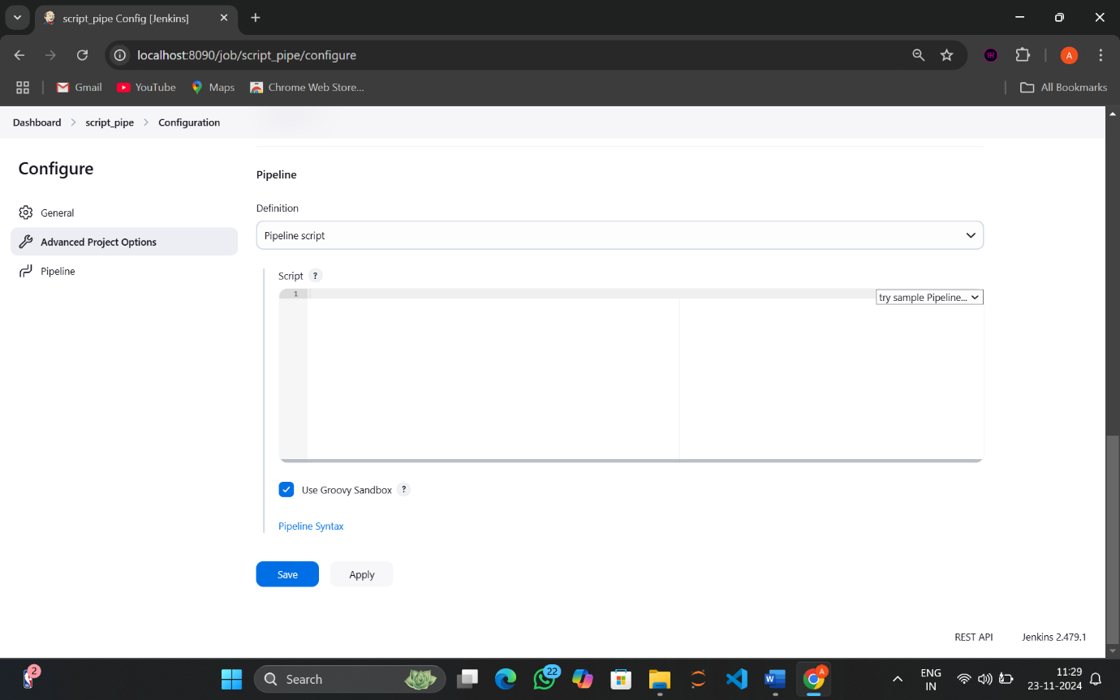

9.In definition click on pipeline script, and type the script

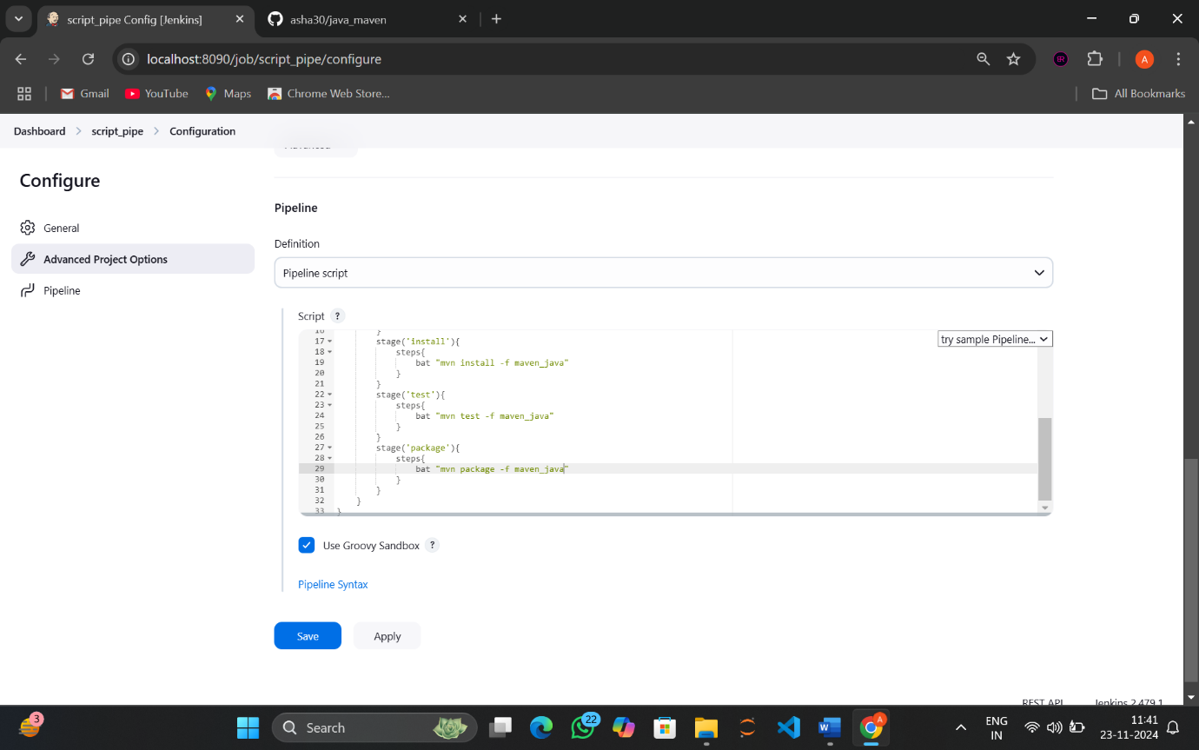

10.now click on apply and save

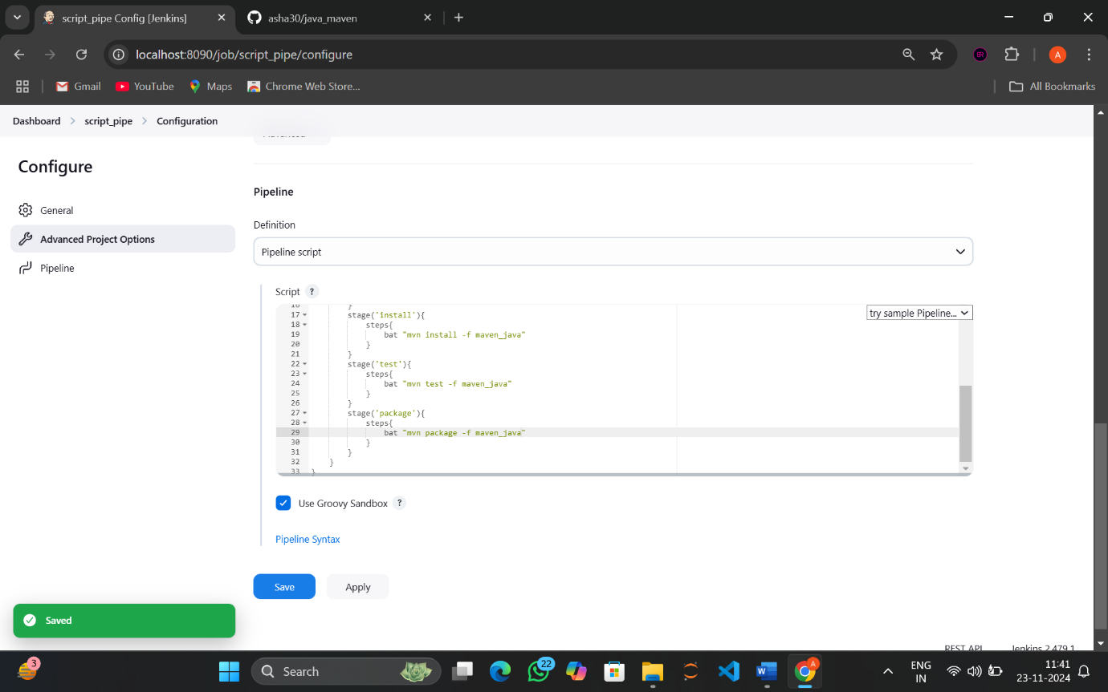

11. click on build now option..

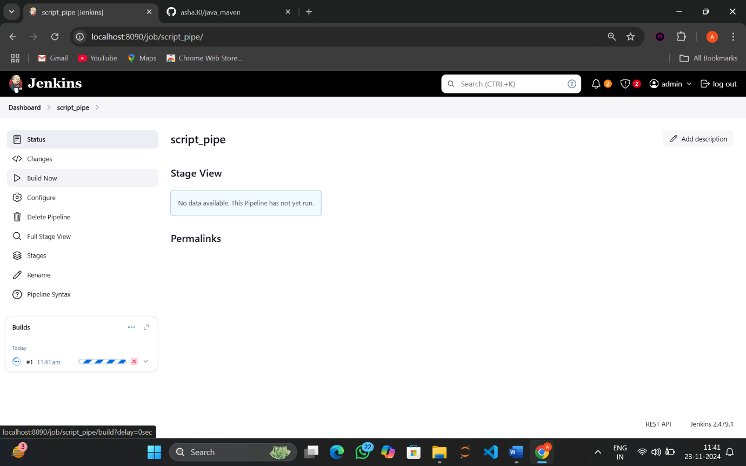

12.wait until the stage view turns green..

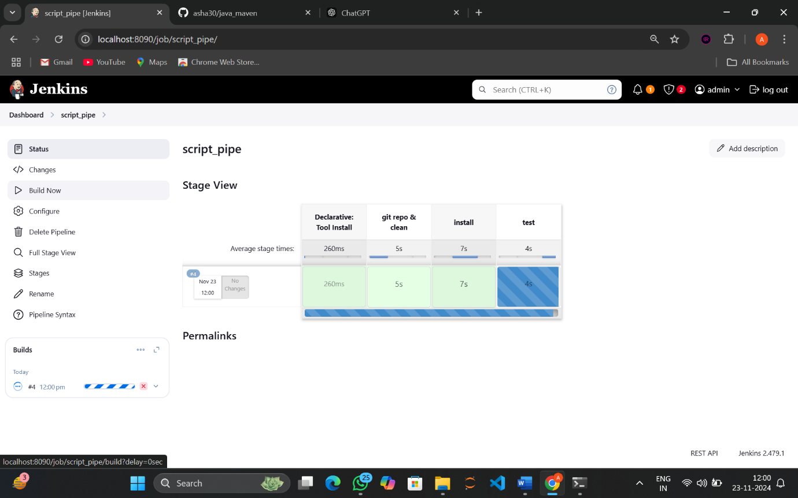

13.build is successful !!!

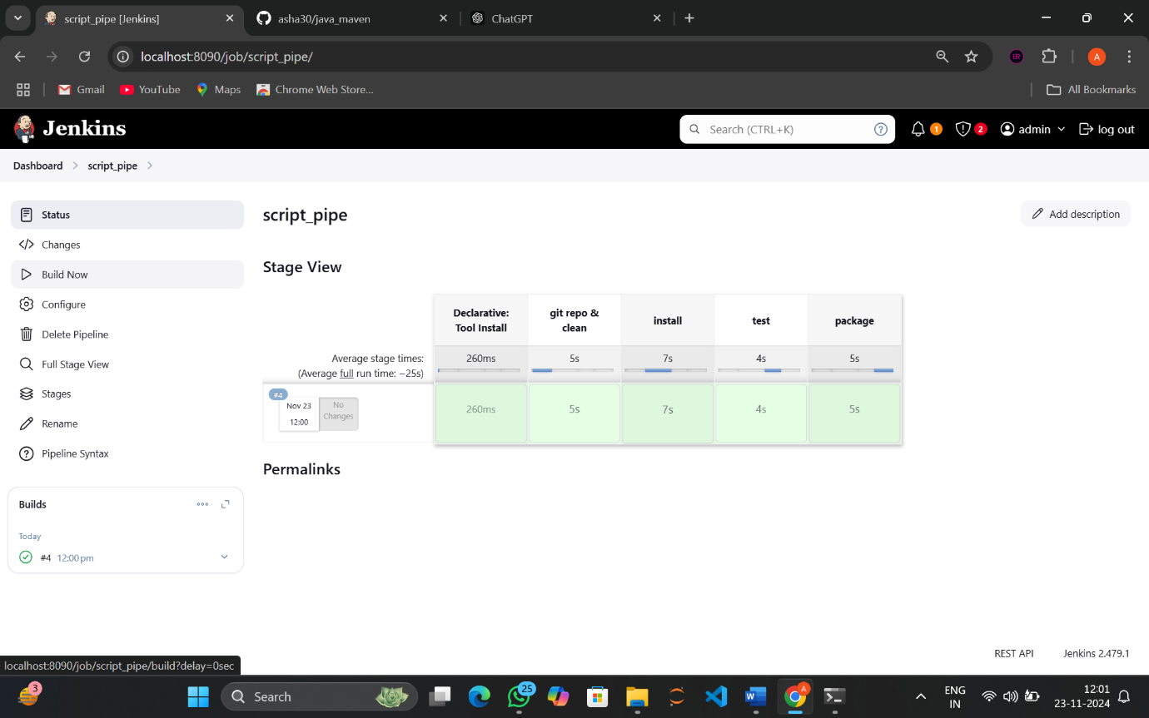

14.again go back to configure and select general option.

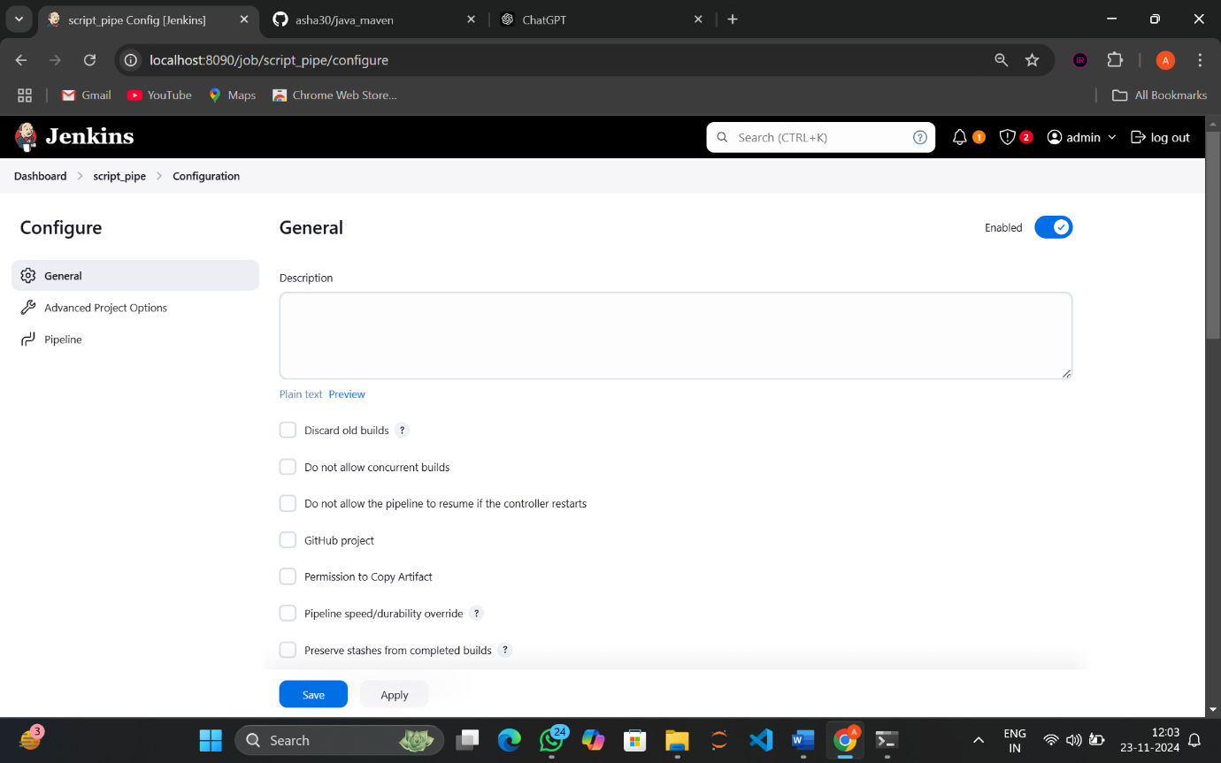

15.In build triggers select build periodically

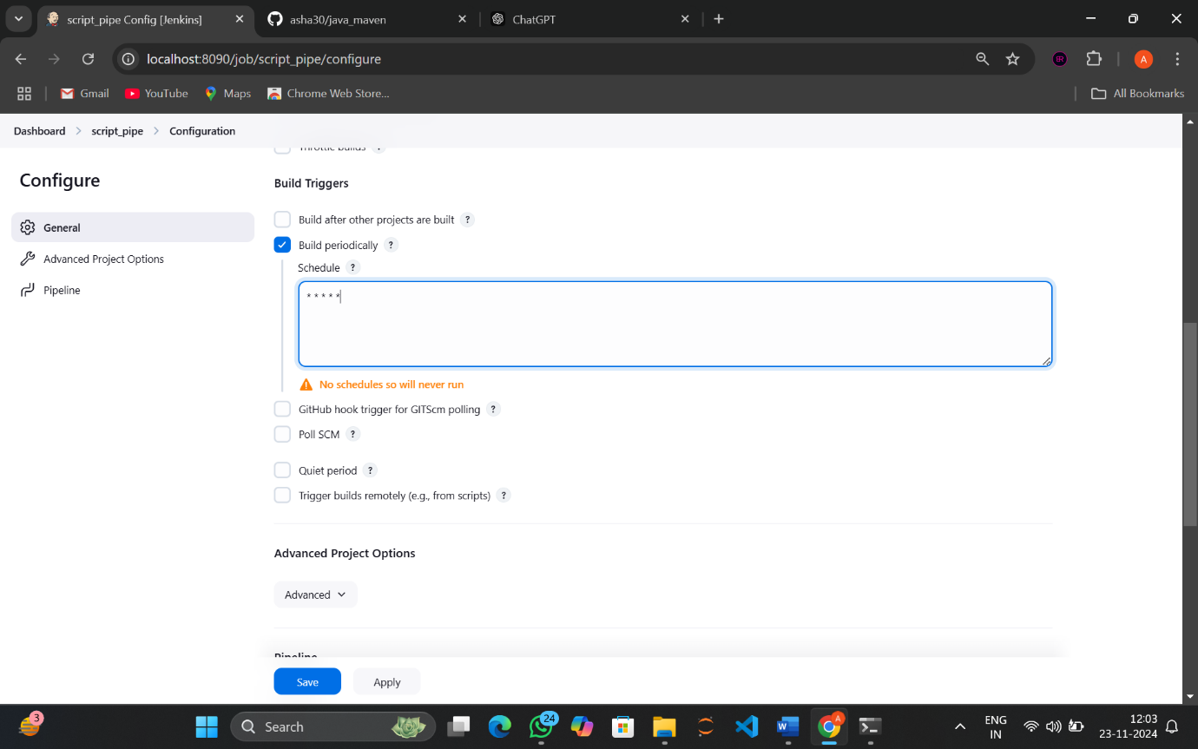

16. give schedule as * * * * * and click on apply then save

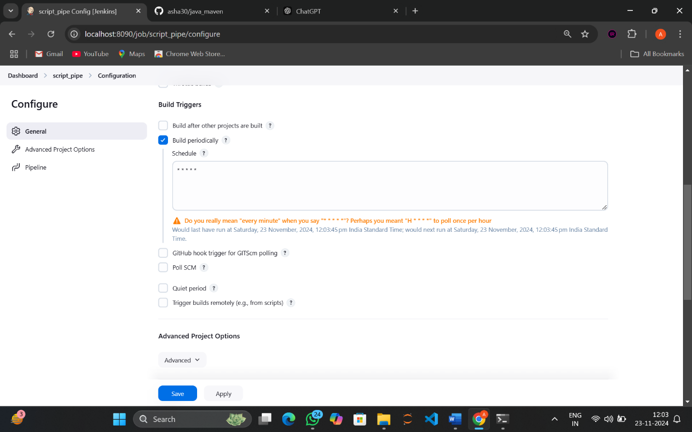

17.Now click on build now , wait until it builds

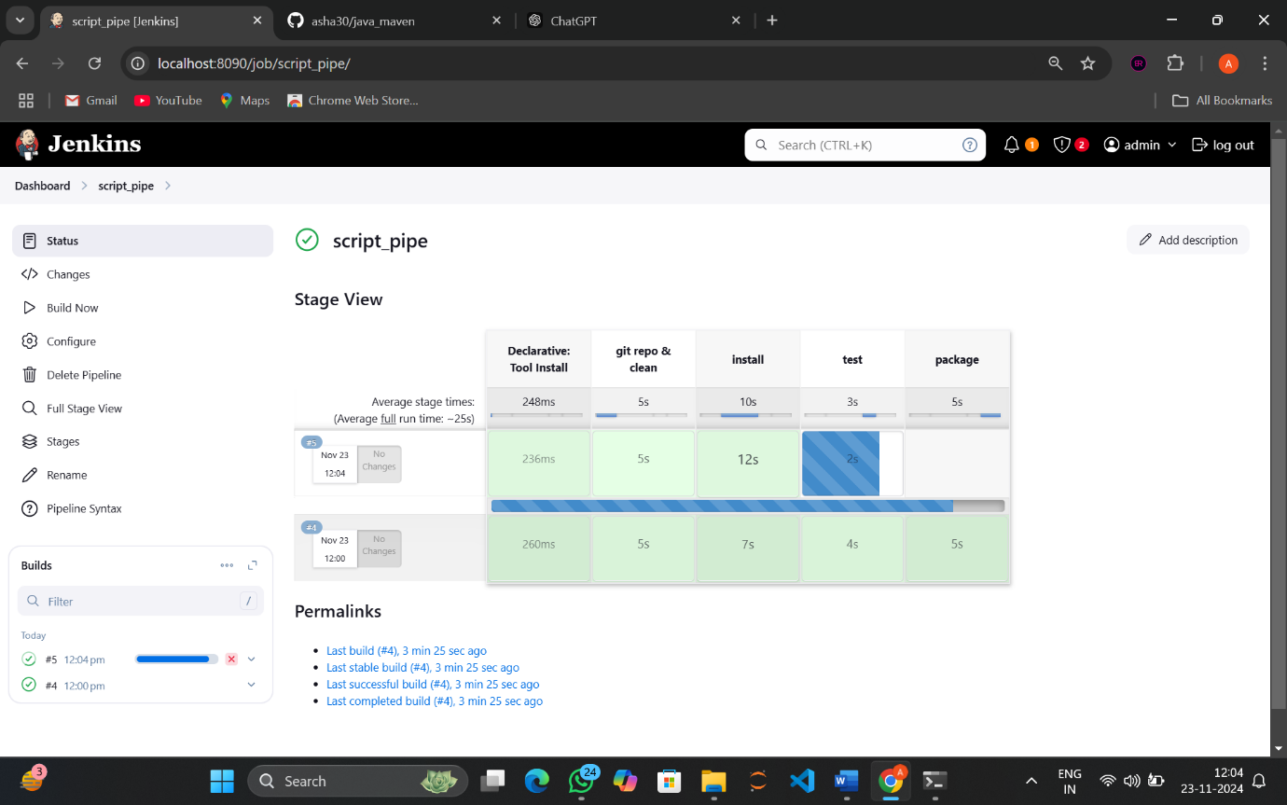

18.build successful !!

